**AWS DEVOPS**

**INTERNSHIP PROJECT-2**

**DEPLOY WORD PRESS WITH AMAZON RDS**

**WORDPRESS**

Word press is a popular open-source content management system user to easily create, manage, and publish wed sites and blogs. It provides a user-friendly interface customizable themes and wider range of plugins and extensions making it suitable for various types of websites from simple blogs to complex e-commerce platforms.

**STEPS TO DEPLOY**

* Login into console, Search for RDS and click on Create Database
* 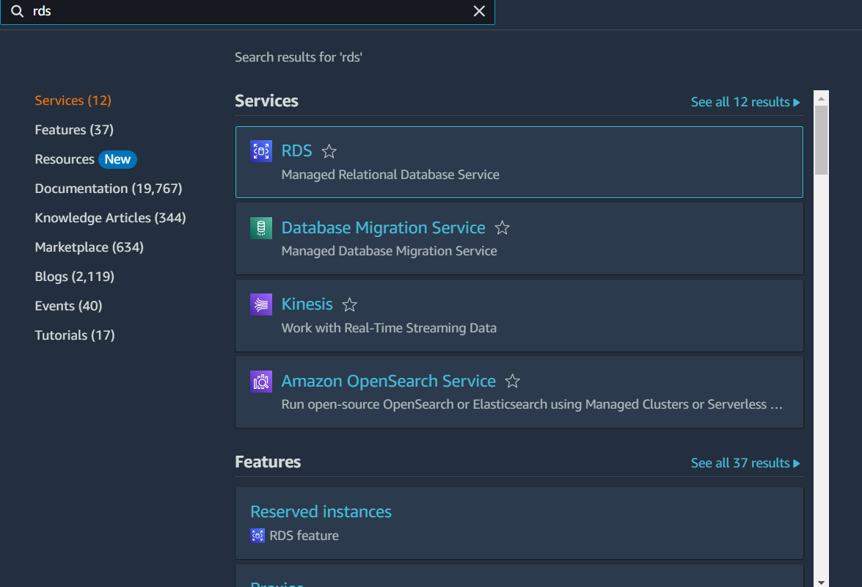Select the standard create, engine options, version, Template, storage-type, select connectivity and click on create database.

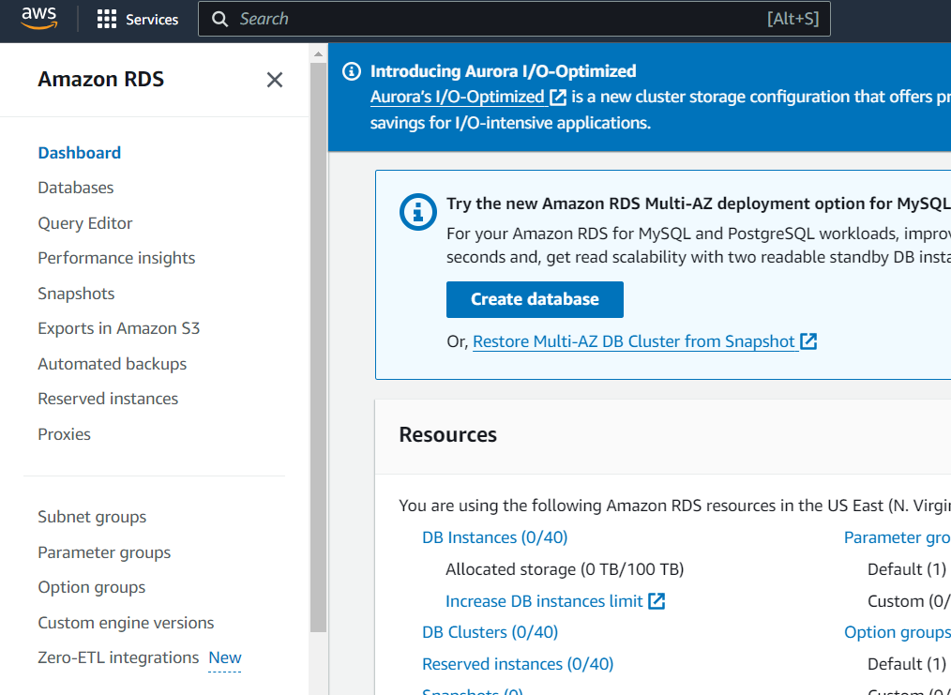

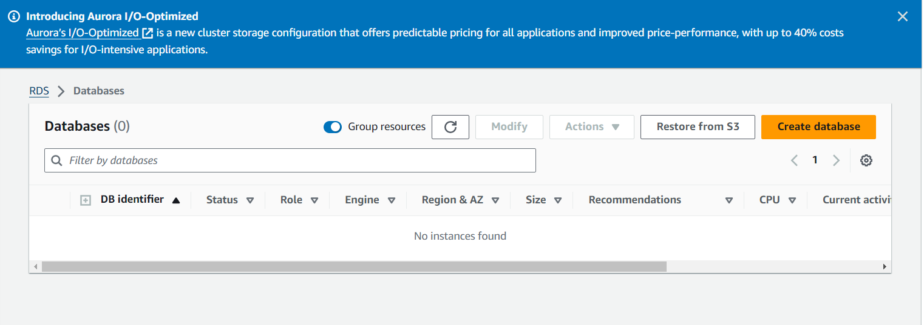

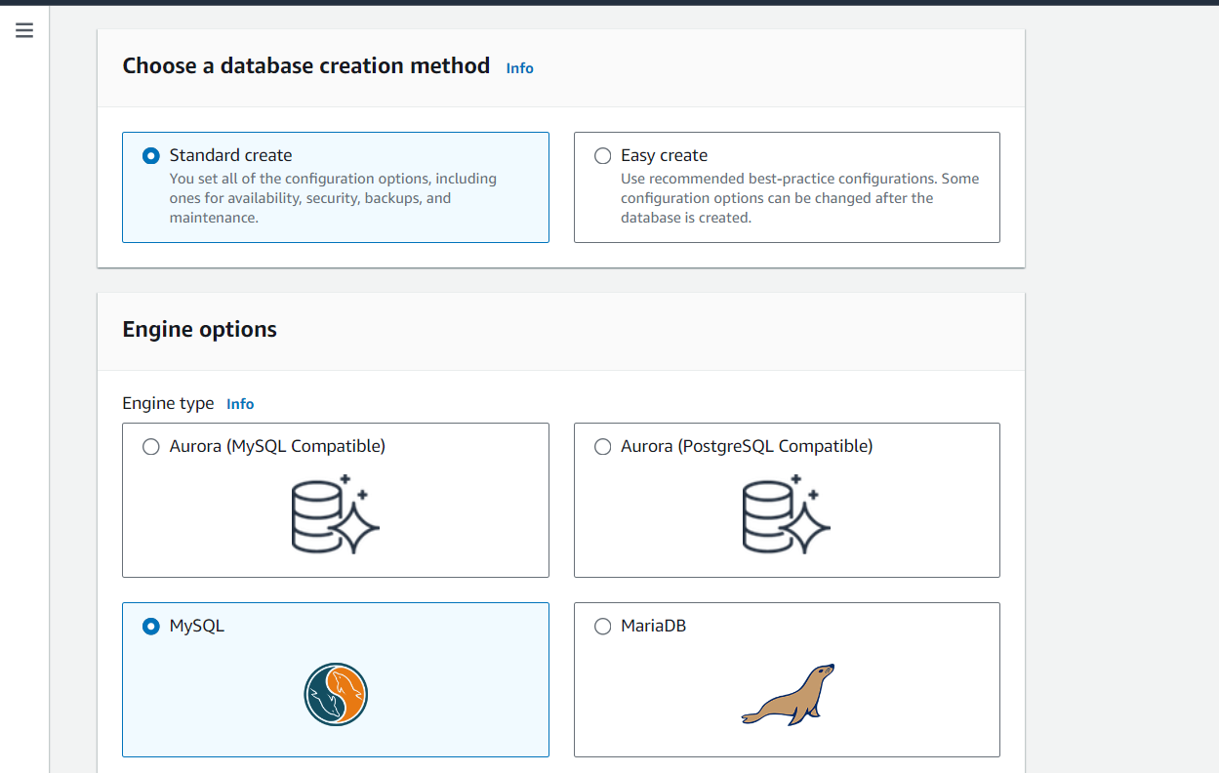

DB Subnet group is selected by default.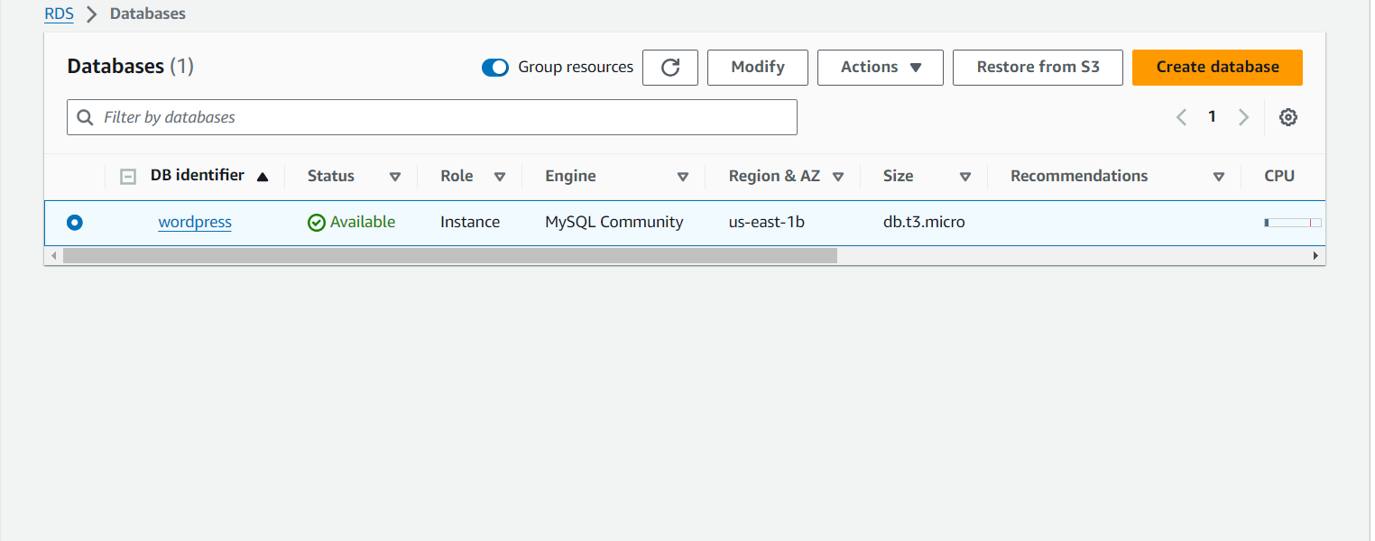

* We, have created database successfully as shown in figure.
* Now, create EC2 instance and add port 22 and 80 port in security groups.
* 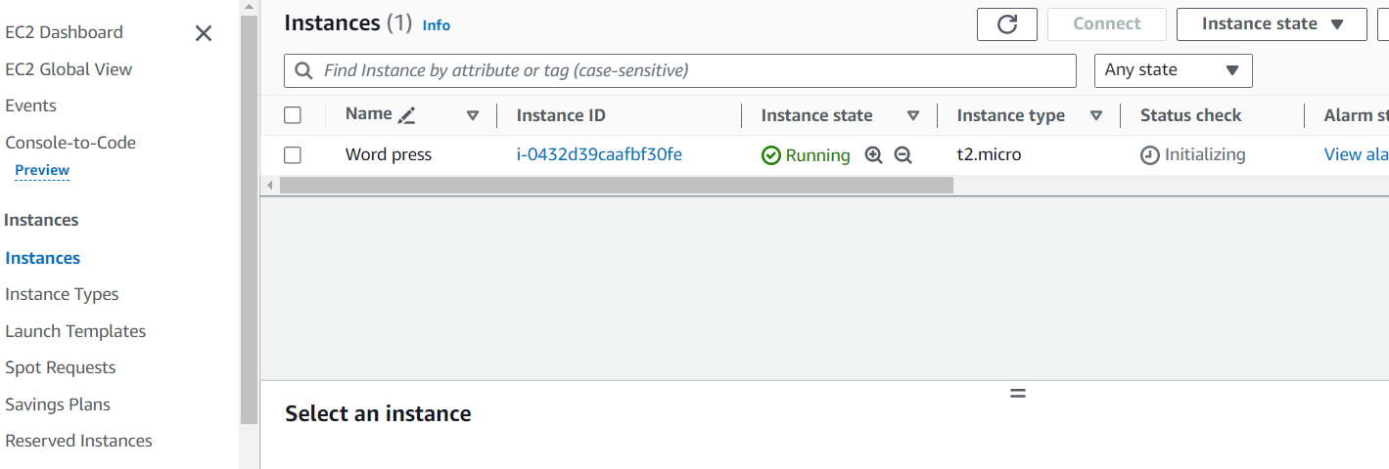Now connect instance with SSH command and update it with <sudo yum -y update>
* And install MYSQL and HTTP.
* Now go to database, click on security group link it opens security group click on inbound rules select on sources select on EC2 instance security group.
* 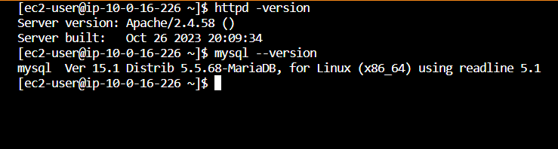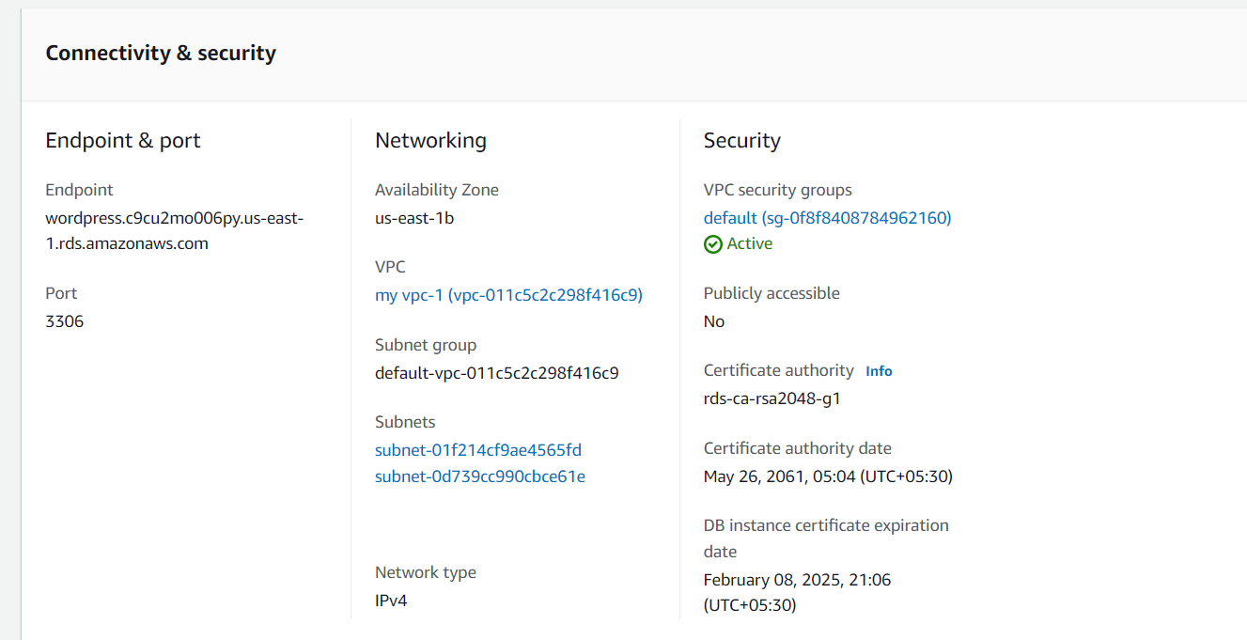Install MYSQL and HTTP.
* Access the MYSQL command <MySQL -h endpoints -u -p>
* Now, create a database user for word press application and give it permission to access the “wordpress”.by commands as

<CREATE USER ‘WordPress’ IDENFIFIED BY ‘WordPress-pass’;

<GRANT ALL PRIVILEGES ON wordpress. *TO wordpress;

<FLUSH PRIVILEGES

<EXIT  
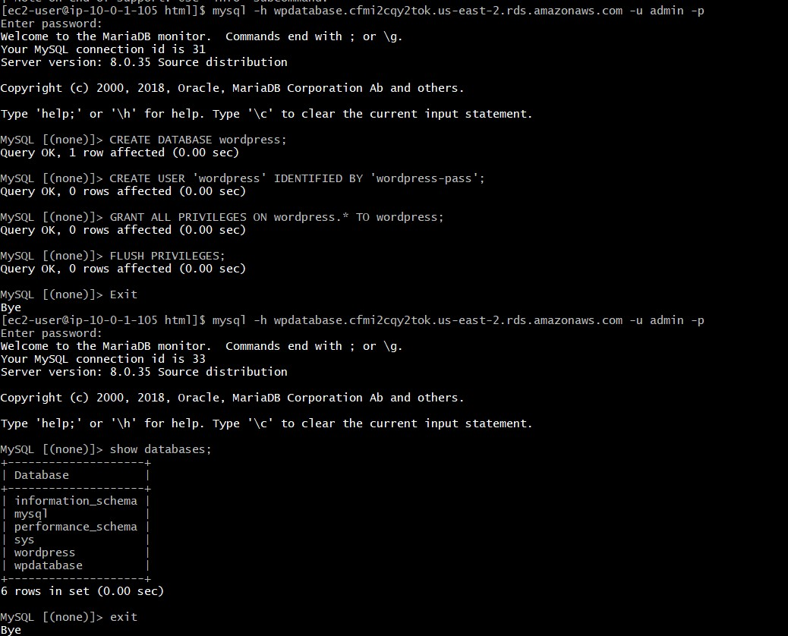

* Now start and enable http and copy the IP and browse it, it shows test page.
* 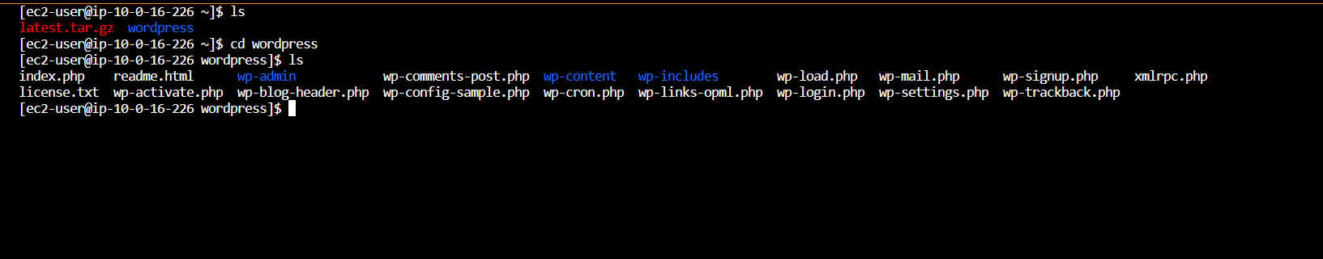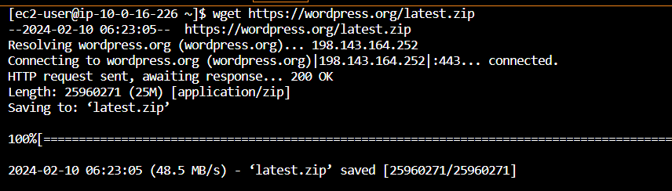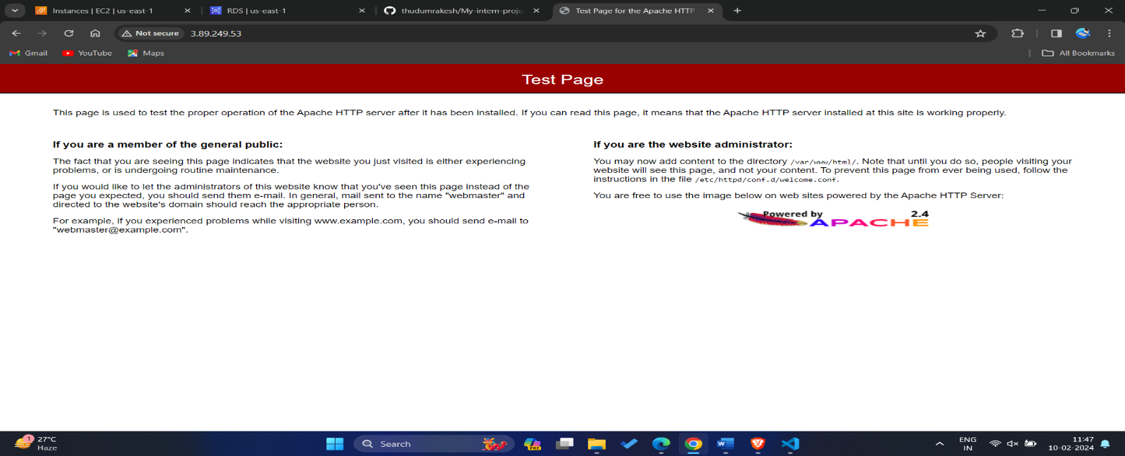Now go browser and download wordpress with <wget> command in gitbash as shown. And unzip the file, we get wordpress.
* Now change the wp-config-Sample.php file to another name with command **<sudo mv wp-config-Sample.php wp wp-config.php>.**

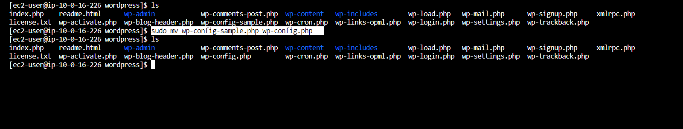

* Now open the configuration file of wp-config.php with command **<sudo vi of wp-config.php>** also generate secret key and edit in it as shown.

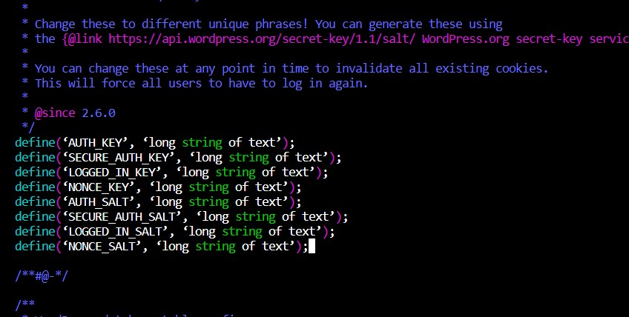 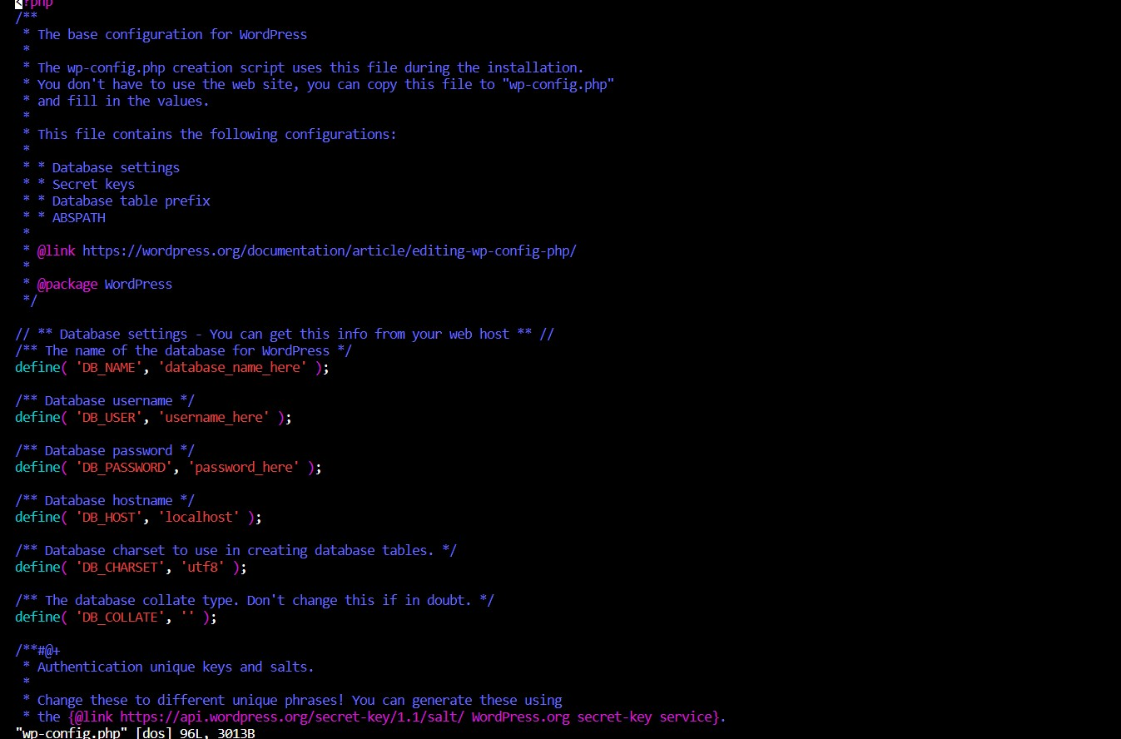

* Now copy the wordpress into /var/www/html/ for hosting, with command of <**sudo cp -r wordpress/* /var/www/html/.**
* Restart httpd and host with the IP it shows welcome page of wordpress.

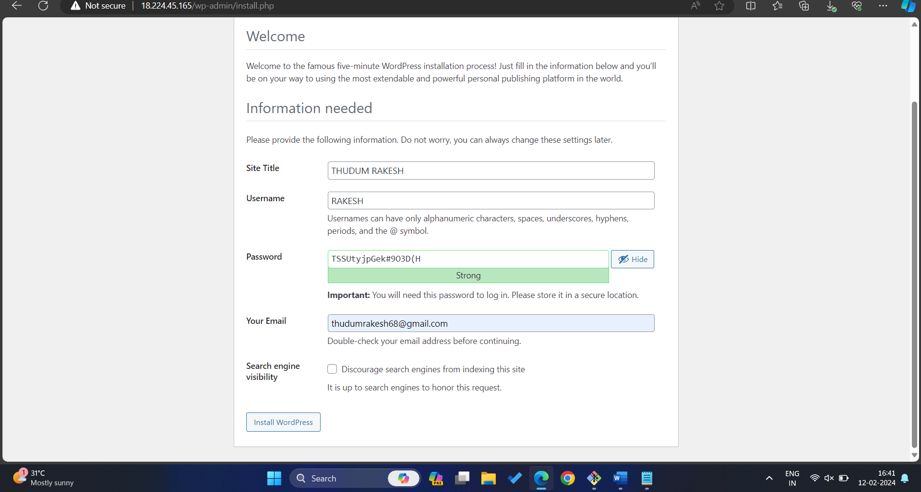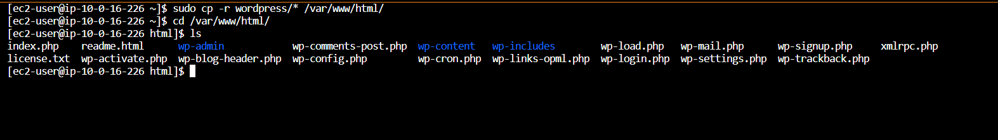

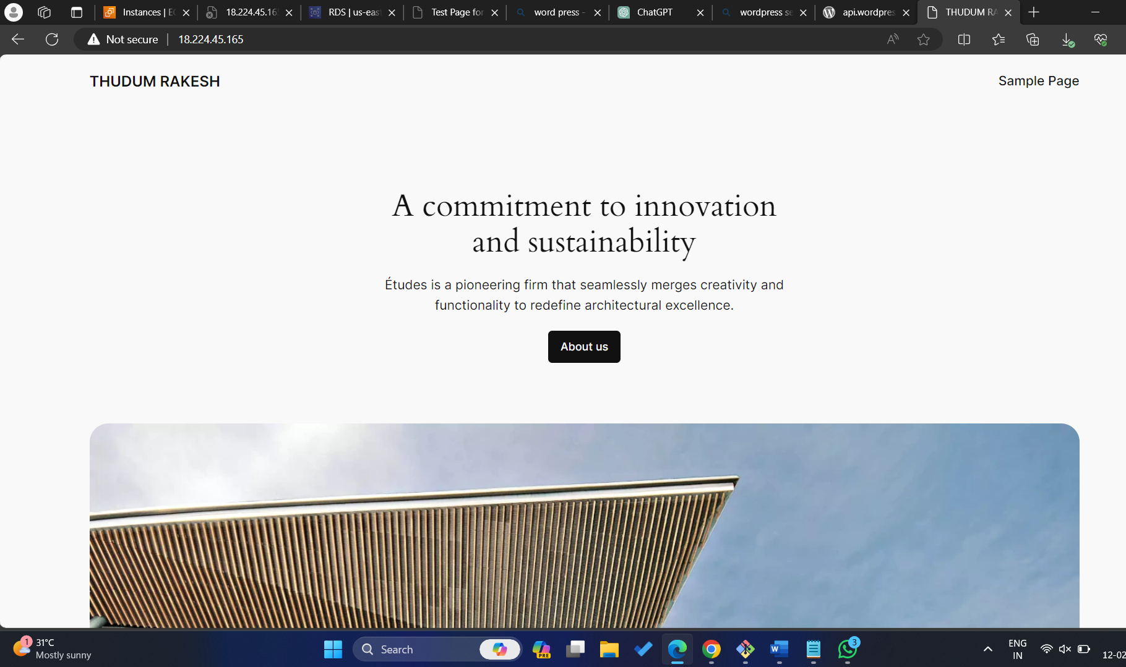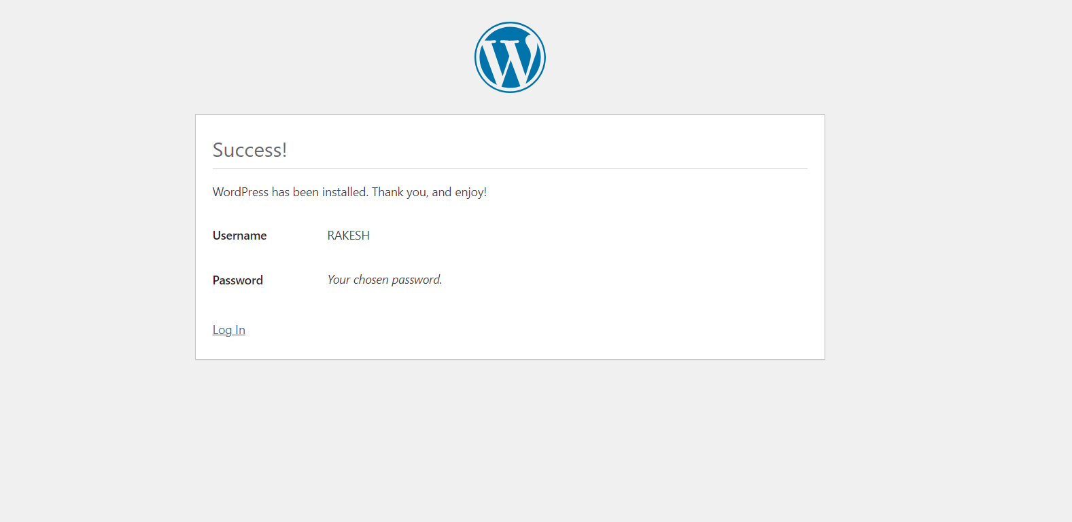

**2.BUILD AND DEPLOY WORDPRESS WEB**

**APPLICATION BY GIT AND DOCKERS.**

1.Create instance, access it with SSH as shown.

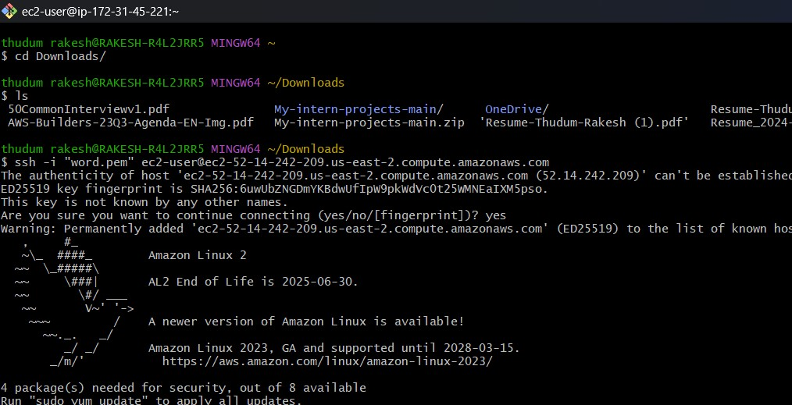

2. Install docker with command **<sudo yum -y install docker and sudo systemctl start and enable**>it as show and check the status as give in picture.

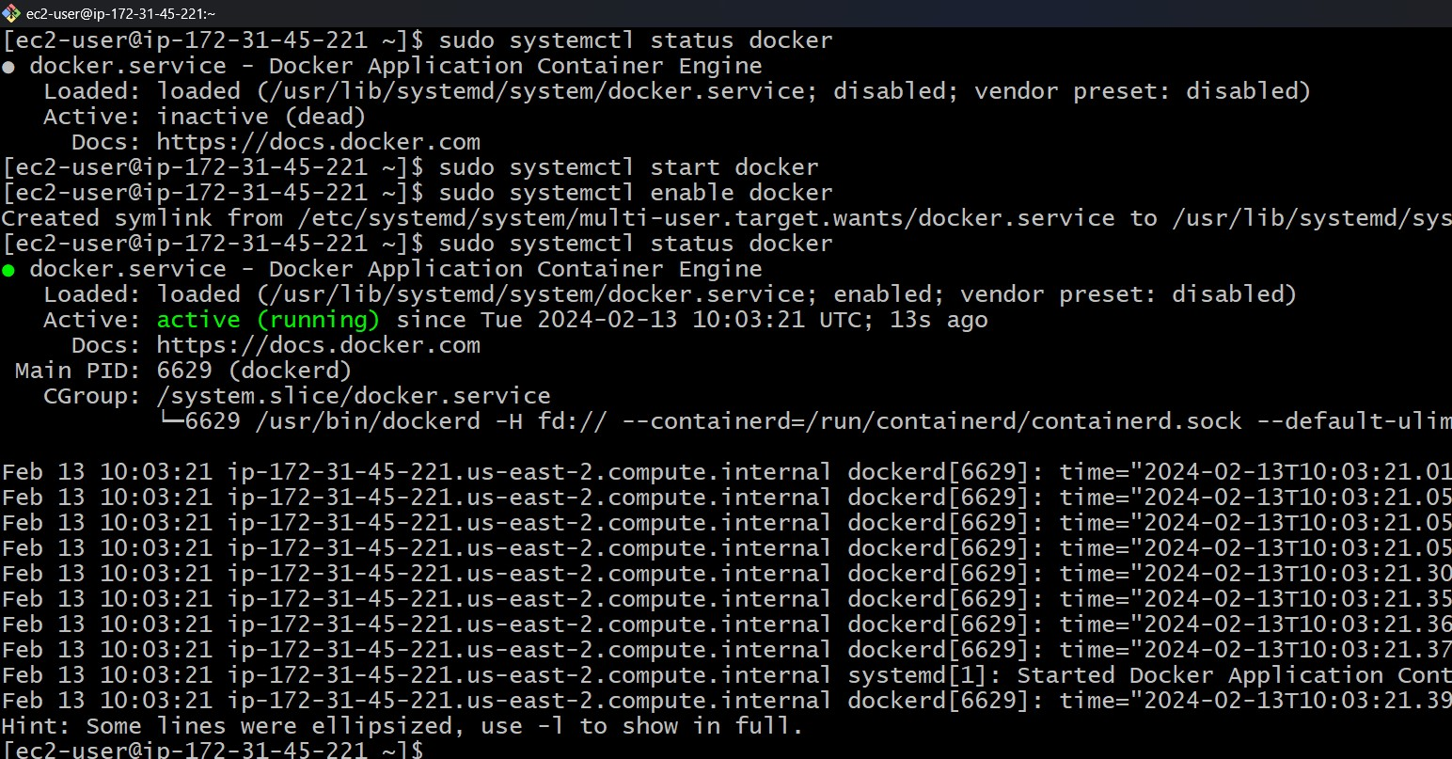

3.Now changing the permissions on docker socket file /var/run/docker.sock is necessary to allow non-root user to interact with docker daemon. With command <**sudo chmod 666 /var/run/docker.sock**. and also command for <**sudo usermod -aG docker ec2-user**> for usermod to add the user to the specified group.

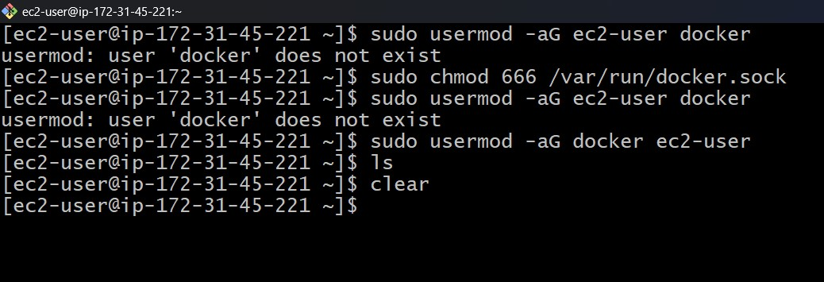

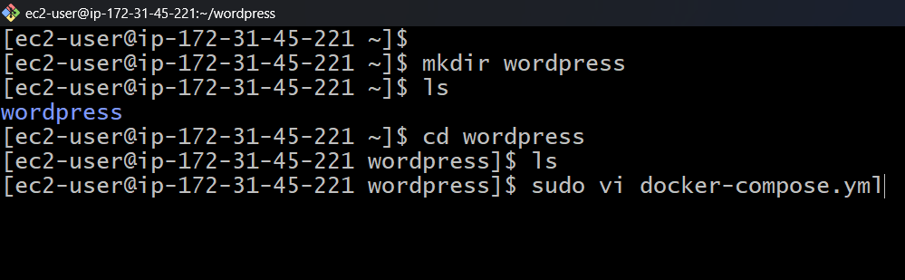

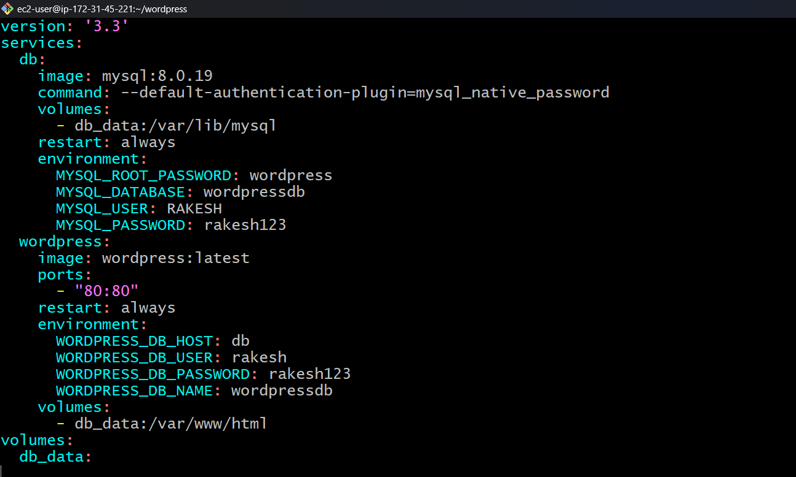

4. Create a directory WordPress and create a file of docker-compose.yml and script as above

5. Now copy the Ip of instance, browse it. It shows the page of word press. Fill the all details   
 and login then it open wordpress page.

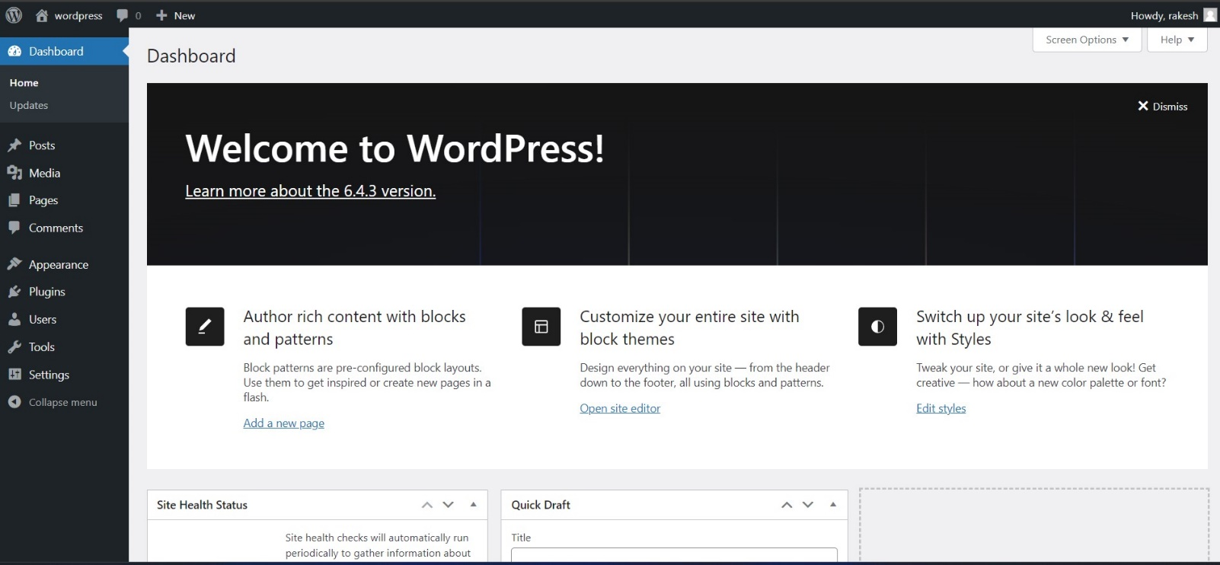

**3.BUILD AND DEPLOY WORDPRESS APPLICATION BY**

**USING USER-DATA.**

1.Open console open instance section, scroll down we can advance settings click on it and in user data and enter data as shown below, click on launch instance.

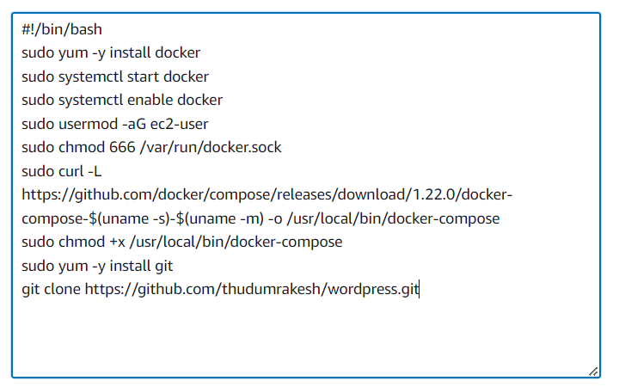

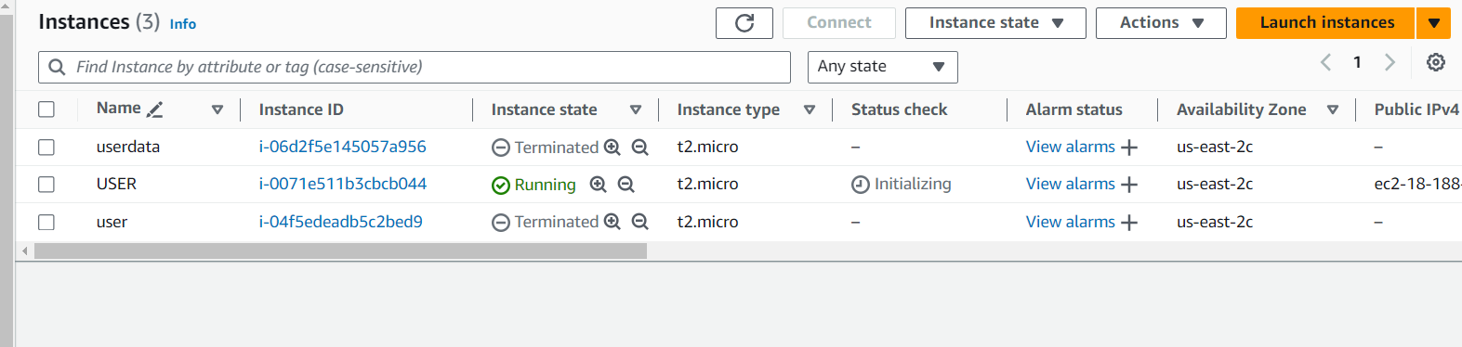

2. Check the version of git and docker.

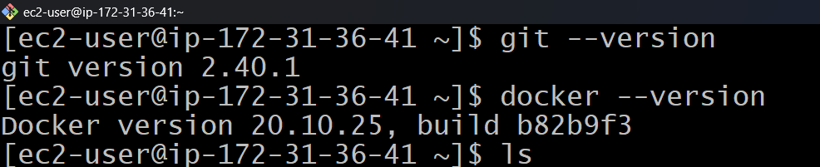

3. Check whether the git repo is clone or not, Once the git is cloned use command **<docker –   
 compose up -d>**

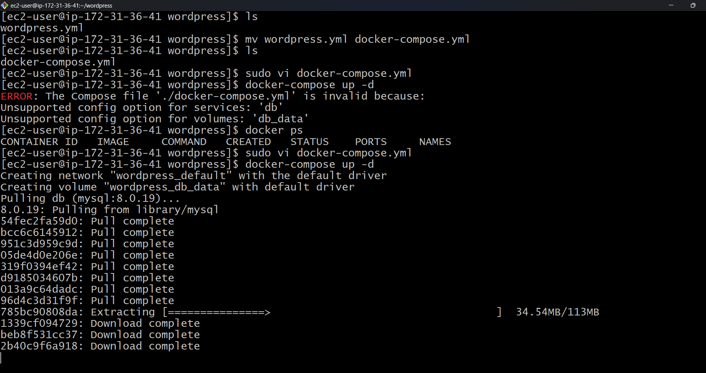

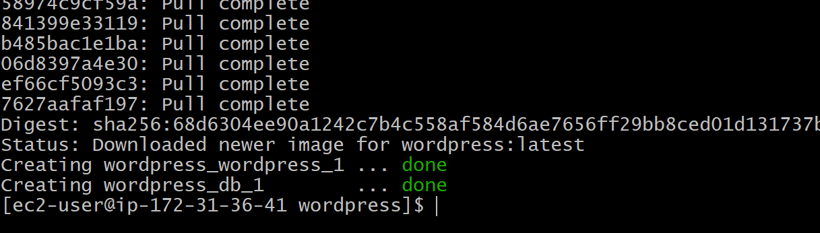

4. Copy the IP of instance and browse it, then it opens wordpress page as shown in figure.

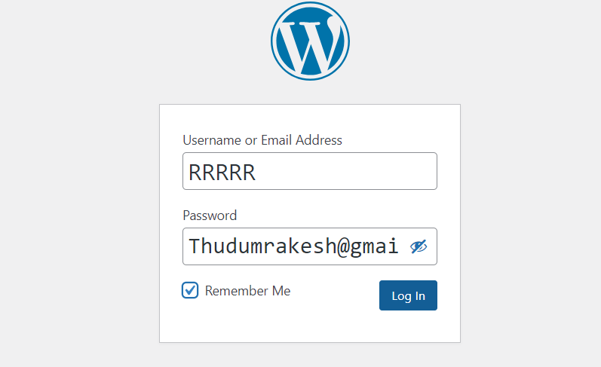

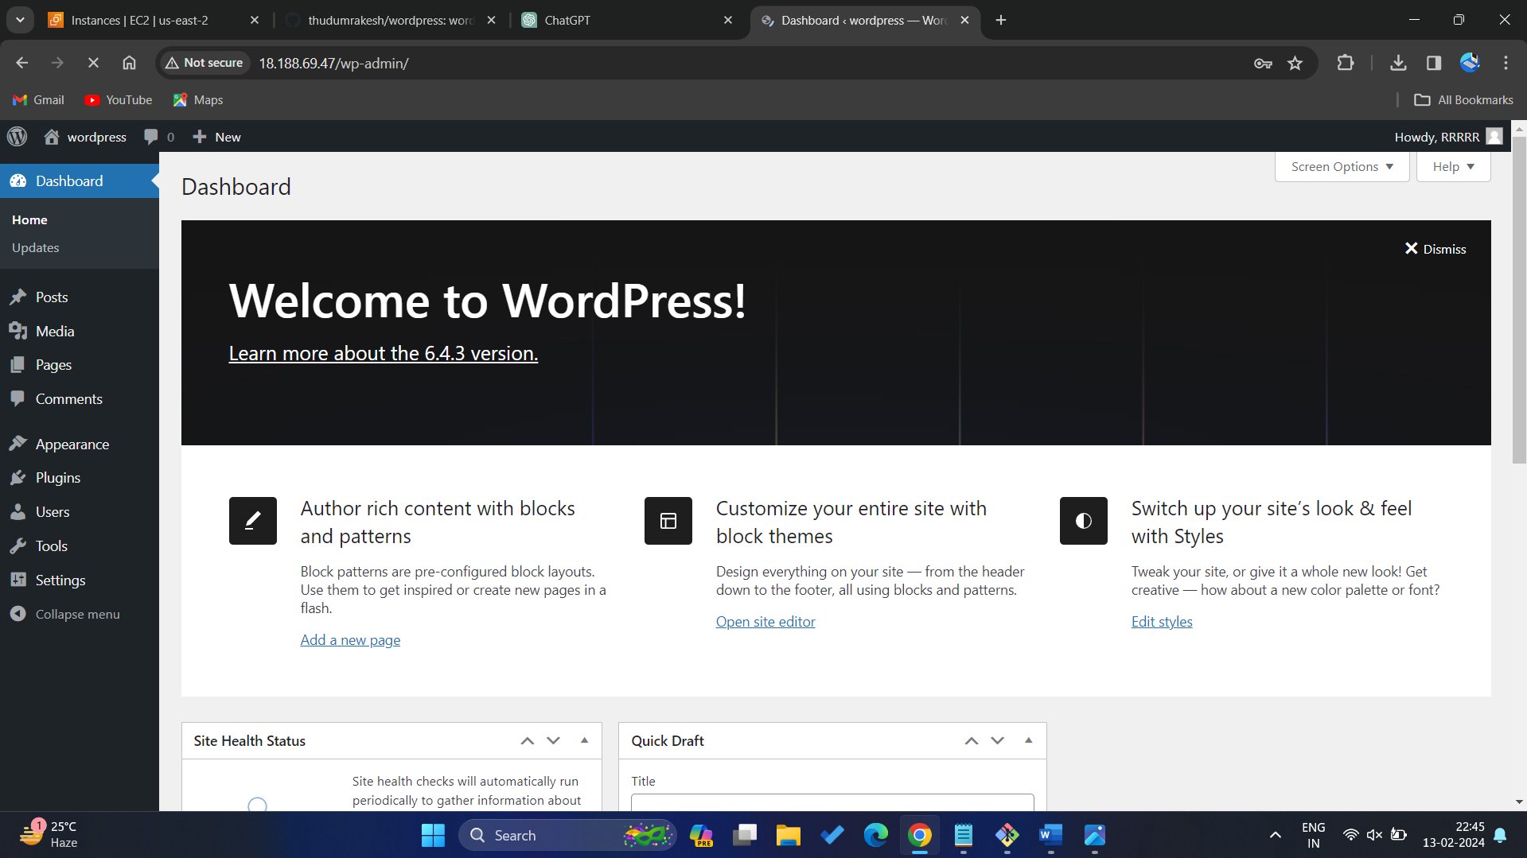

**4.BUILD AND DEPLOY WORDPRESS APPLICATION BY**

**USING BASH-SCRIPT**

1.Launch instance, access it in terminal.

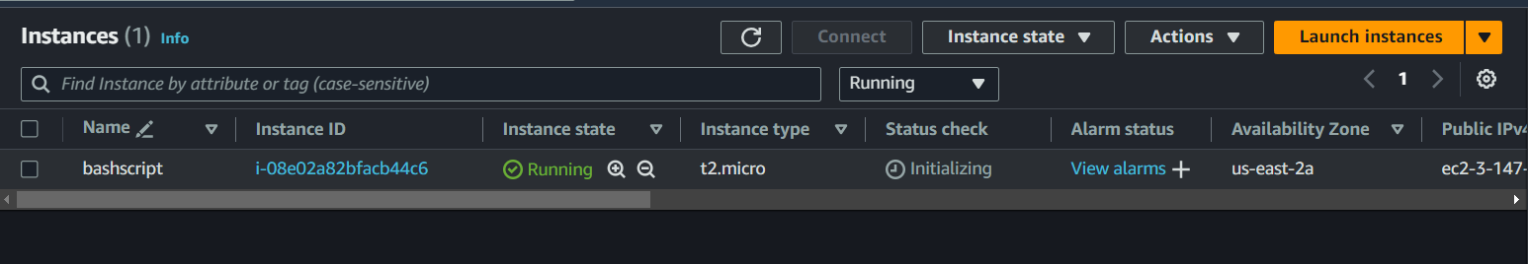

2.Create a data.sh and upload script in it as shown in figure, save it with command wq!.

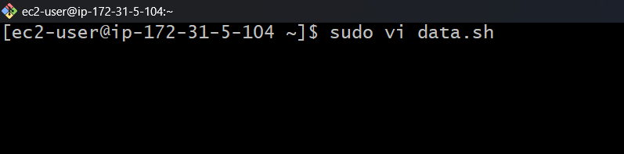

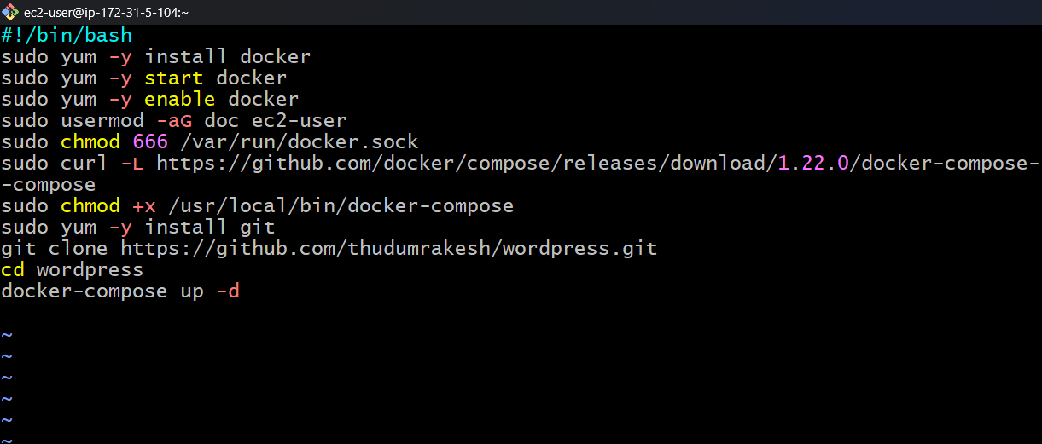

3. Now execute command <**sudo ./data.sh**> to execute the data.sh  
4. Change the permissions of docker.sock with **<sudo 666 /var/run/docker.sock**> and with command <**docker-compose up -d**> , which runs services in background, once it show done, copy the IP of instance browse it, open word press page as shown in figure.

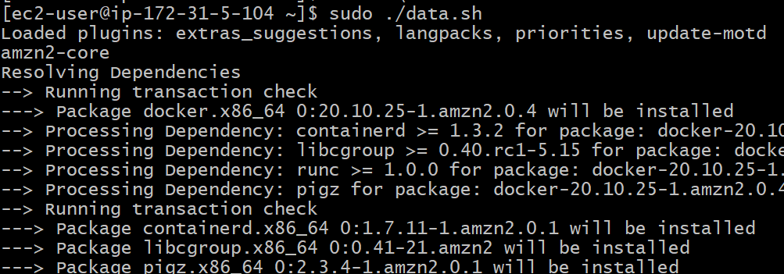

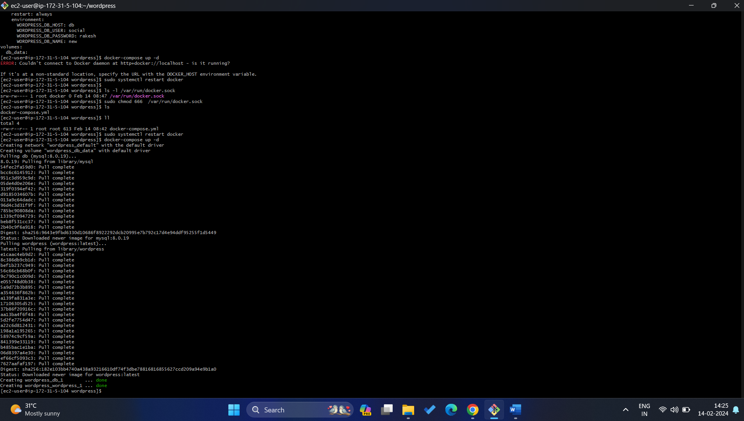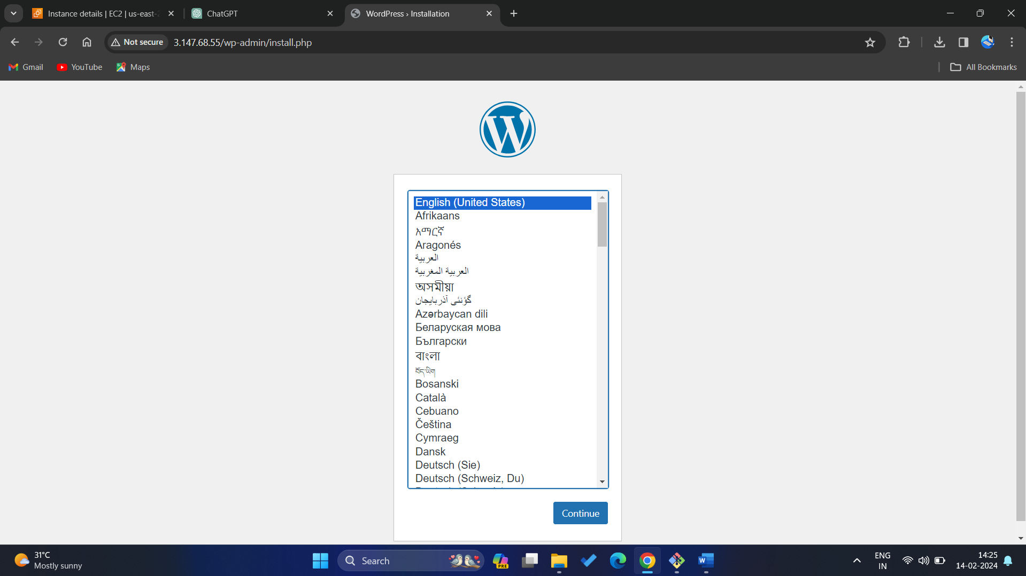

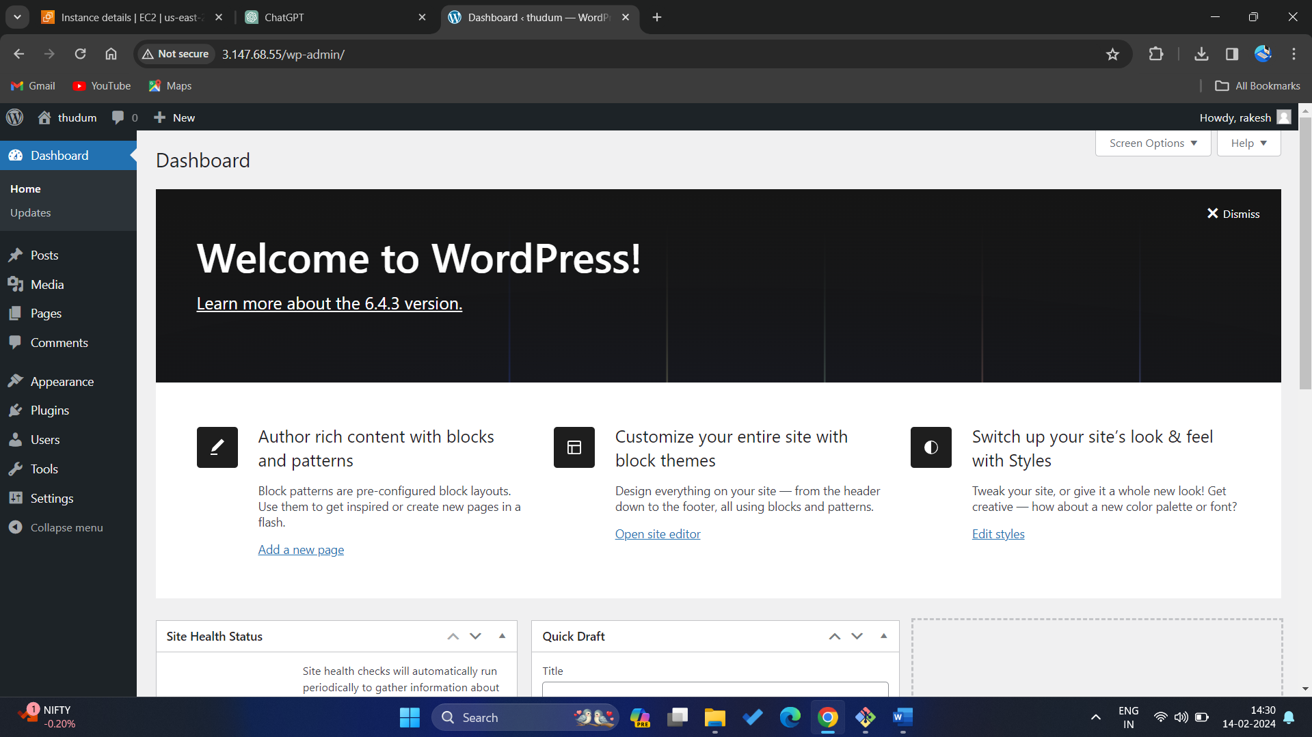

**5. BUILD AND DEPLOY WORDPRESS WITH JENKINS**

**AND GIT**

1.Launch instance access it, and allocate port 22&80 and 8080 for Jenkins. And install git.

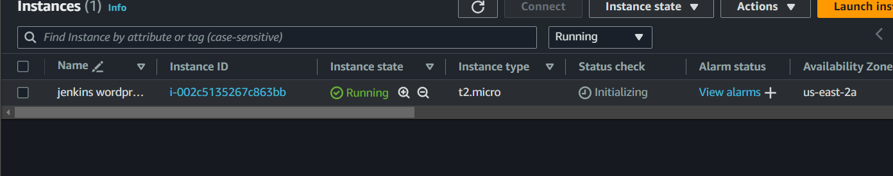

2. Access instance and update it with <sudo yum update> and install java runtime from command <amazon-linux-extras>.

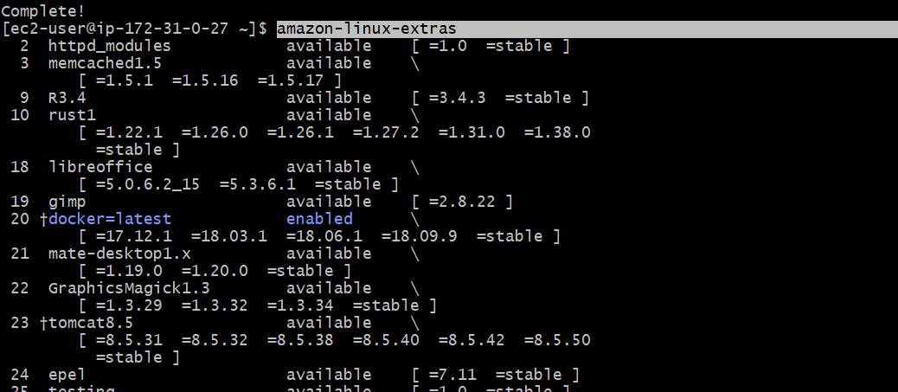

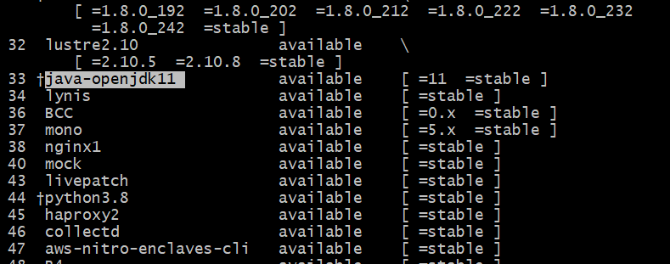

3. Now install java with command <sudo amazon-linux-extras install java-openjdk11> as show in figure.

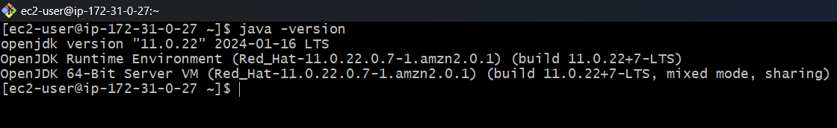

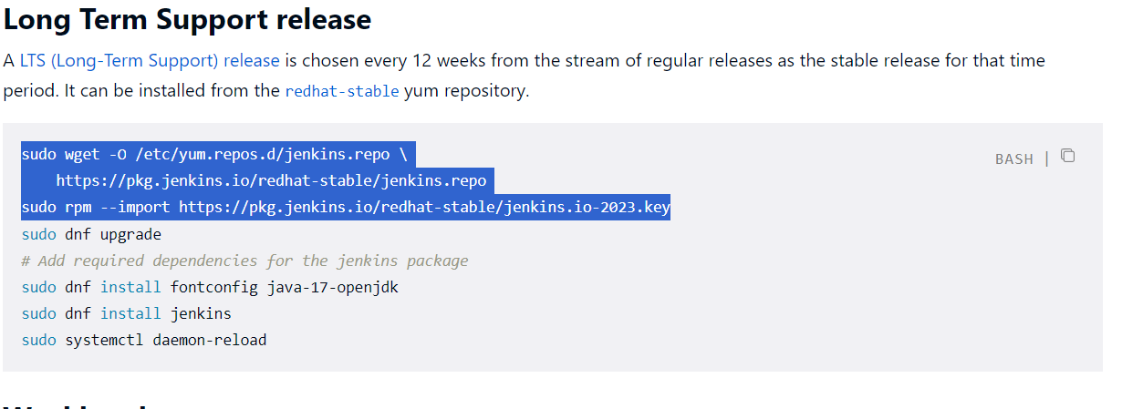

4. Copy the plugins from avoid and install. Now install Jenkins and start and enable it with commands

**<sudo yum -y install Jenkins>  
 <sudo systemctl start Jenkins>  
 <sudo systemctl enable Jenkins>** as shown in below. And check version.

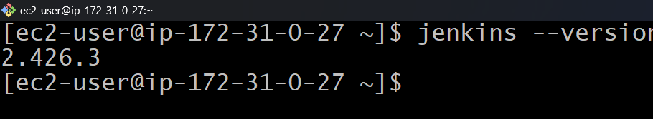

5.Now copy the IP of instance as follow command <IP:8080> in browse it in browser then it opens Jenkins page type the password, Copy the path paste it in terminal then it shows the password copy and paste it.

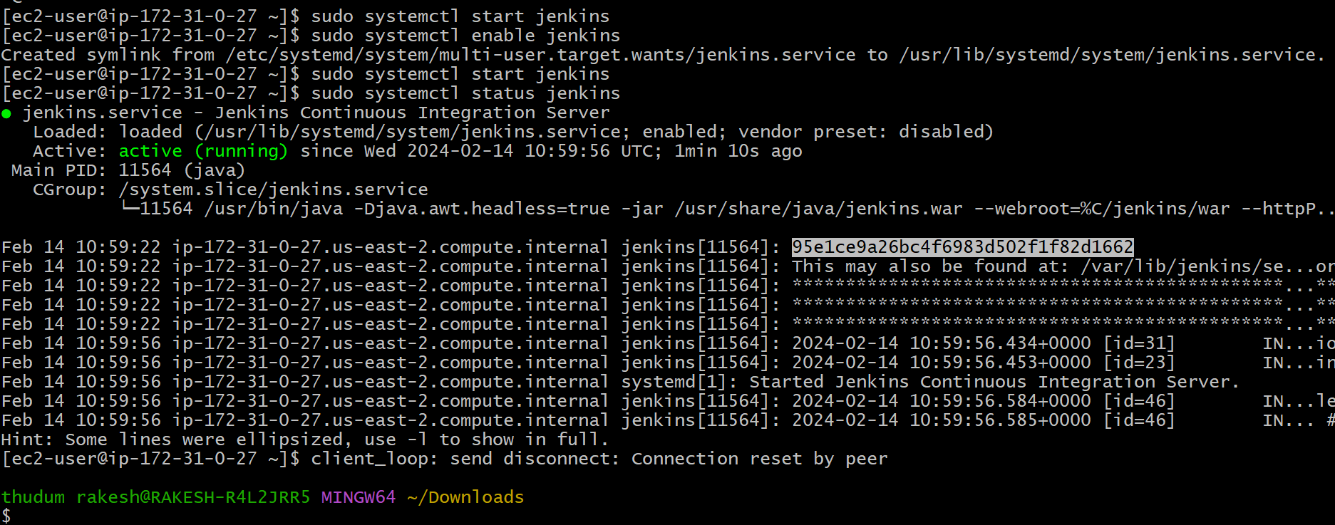

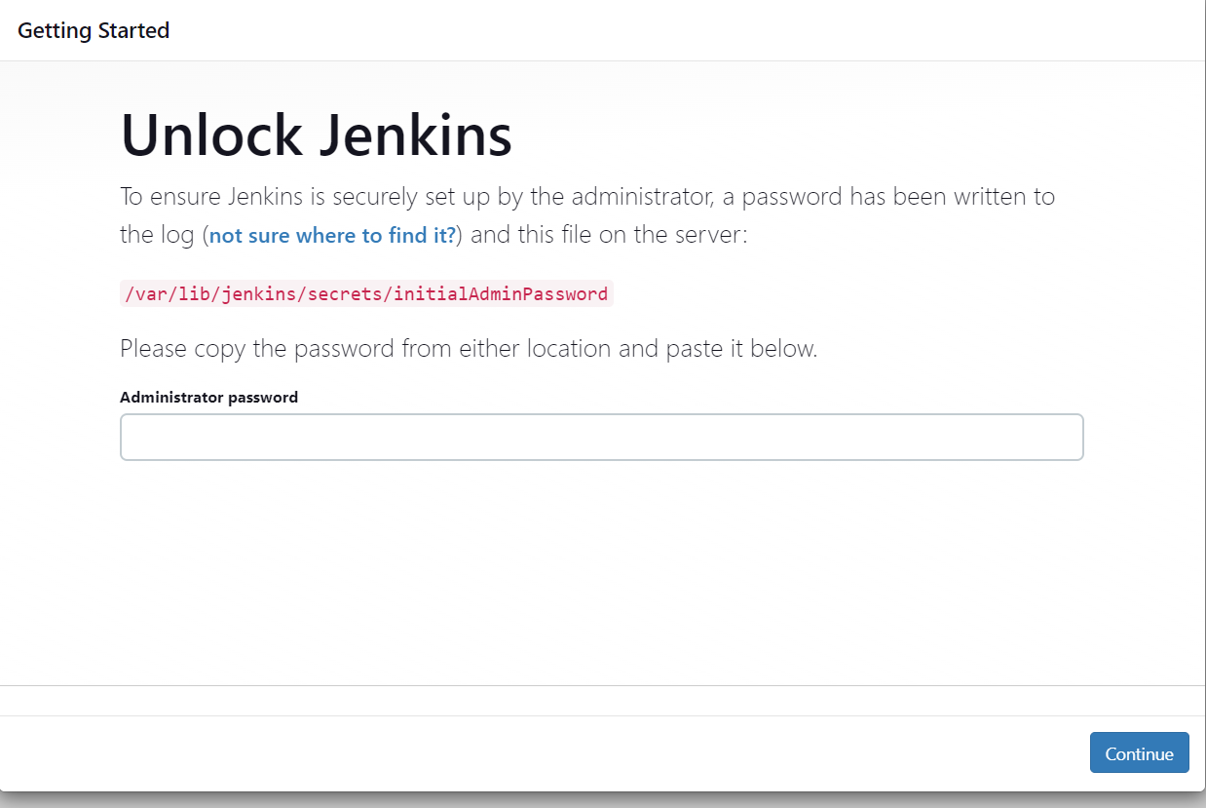

6. Click on install suggested plugins, then it opens a Jenkins enter the details and click on save and continue. It opens URL of Jenkins. Click on save and continue.

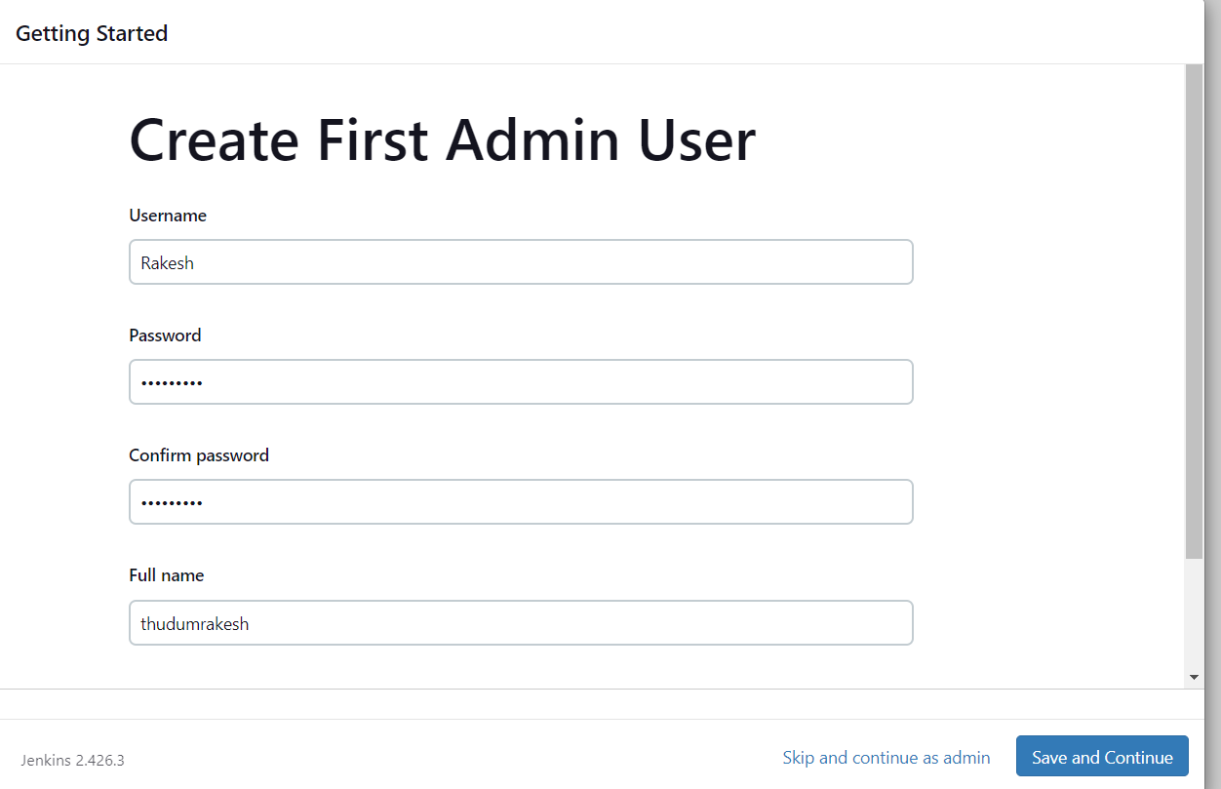

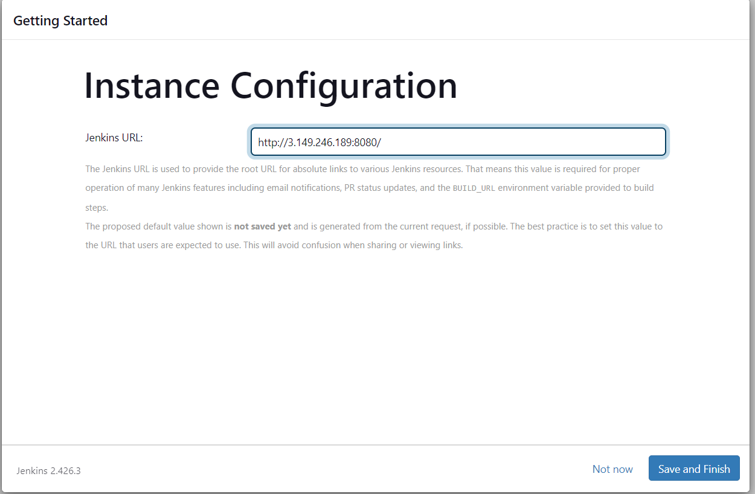

7. It opens a welcome page, click on start using Jenkins. And open a page of Jenkins.

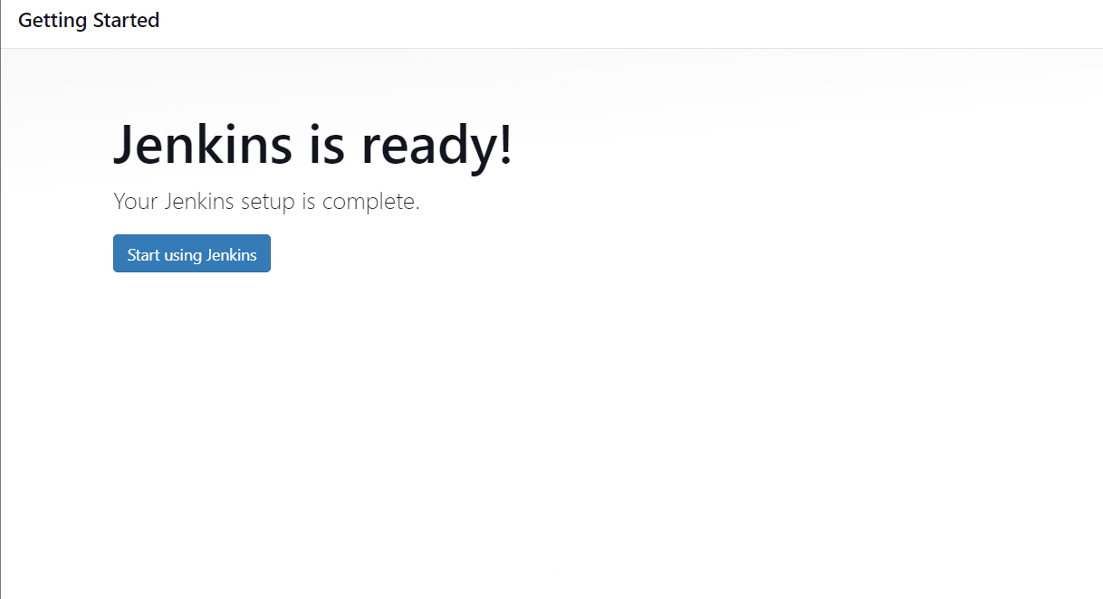

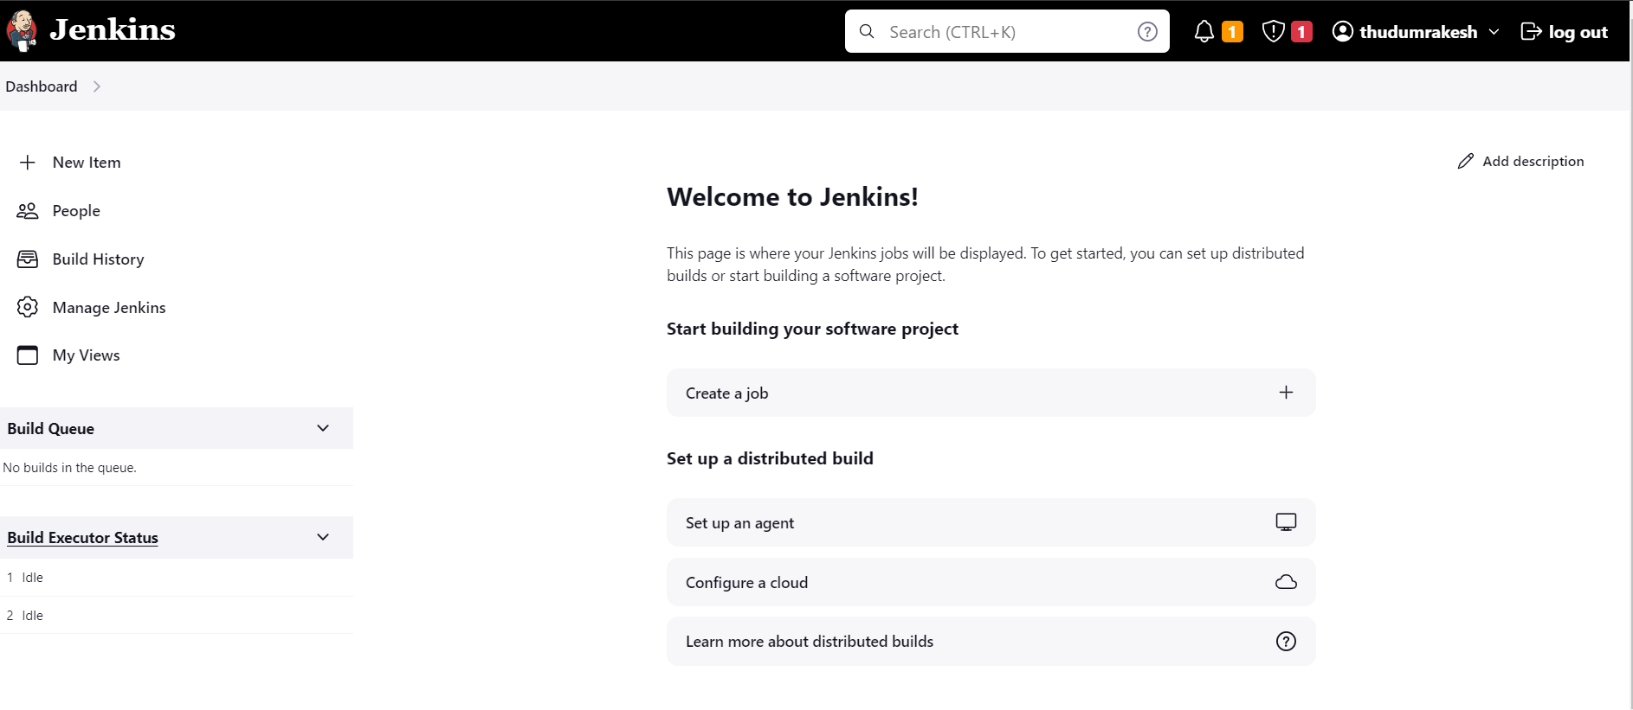

8.Click on NEW ITEM. And select the freestyle and give title. And click on OK.

9. Select the git in source code management. And copy the repo <URL>

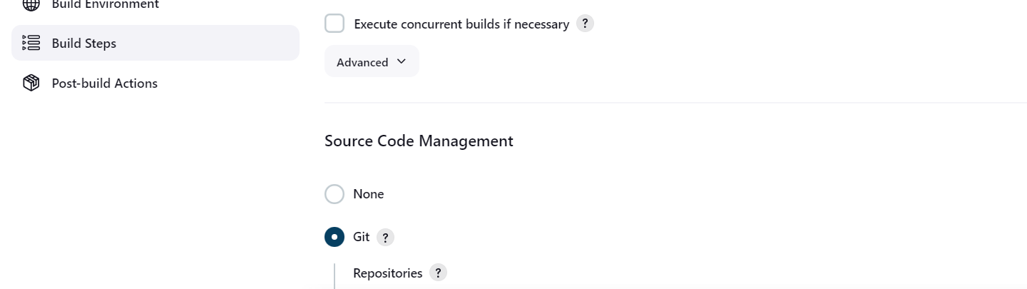

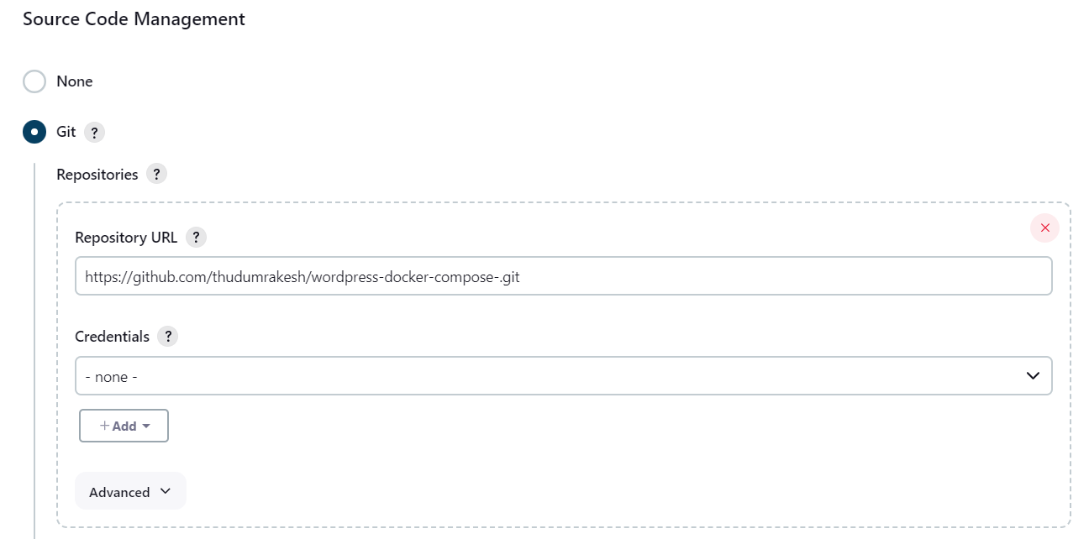

10. Go to build steps and execute shell give command <**docker-compose up -d>** and click on save.

11. Click on build now it shows successful.

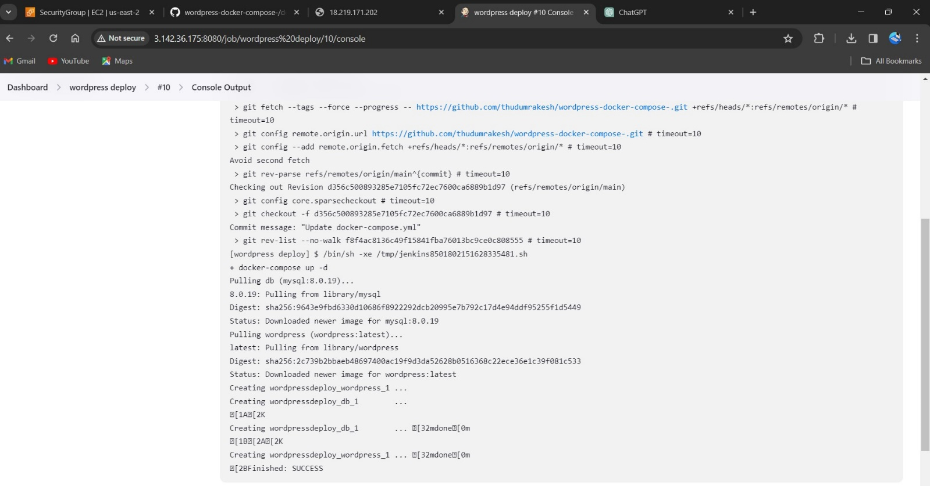

12. Now copy the IP:80 it shows the wordpress page. Enter essential detail the it open Wordpress application.

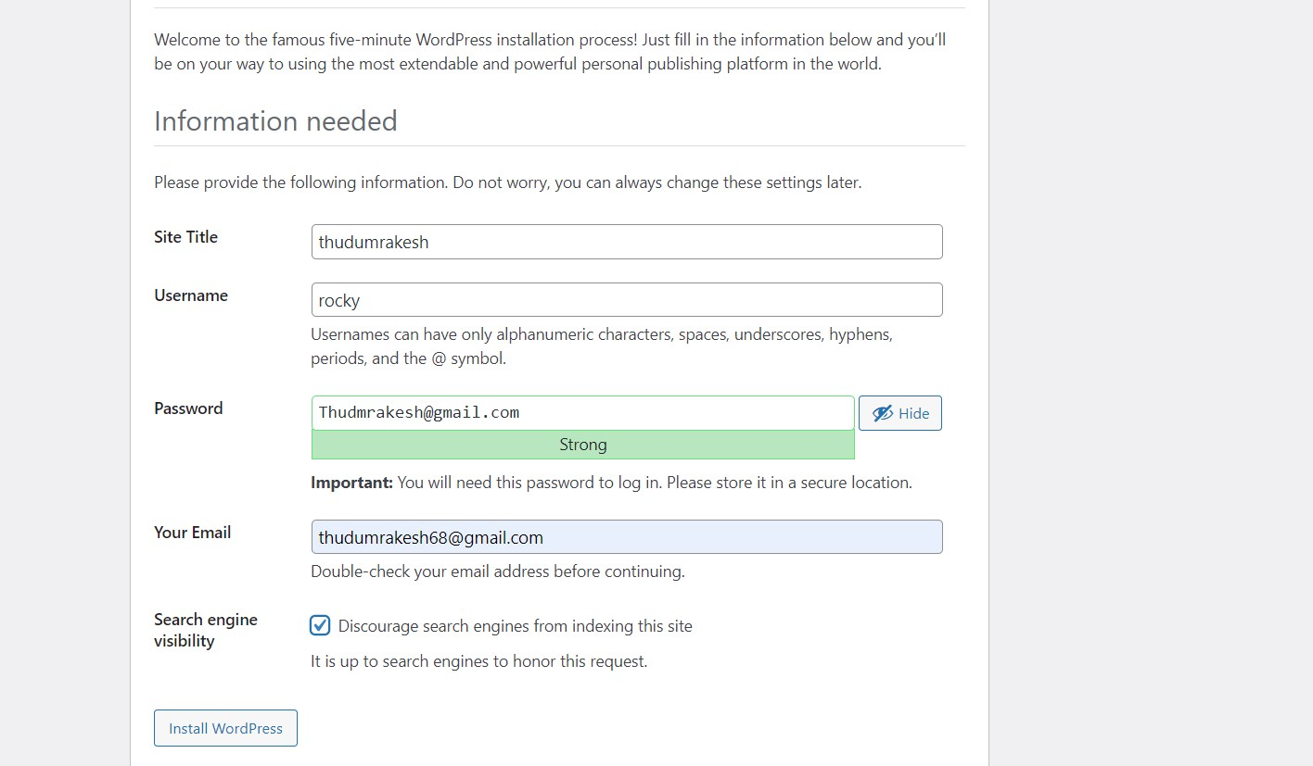

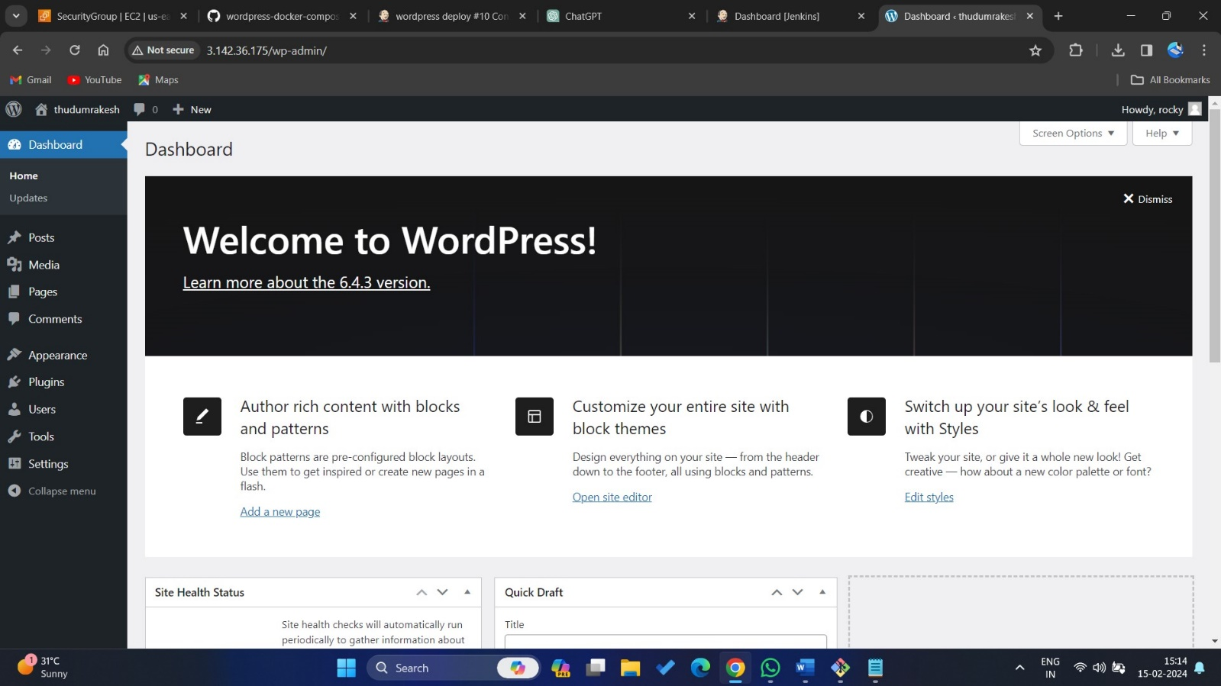

**6. Build and deploy WordPress application by using Jenkins,**

**Git, GitHub and Bash script**

1.Log into Jenkins with Ip:8080 and start Jenkins.

2.Open the Jenkins and click on new item and give name as bash script as shown in picture And click on ok hence it creates item. And give description in the given space.



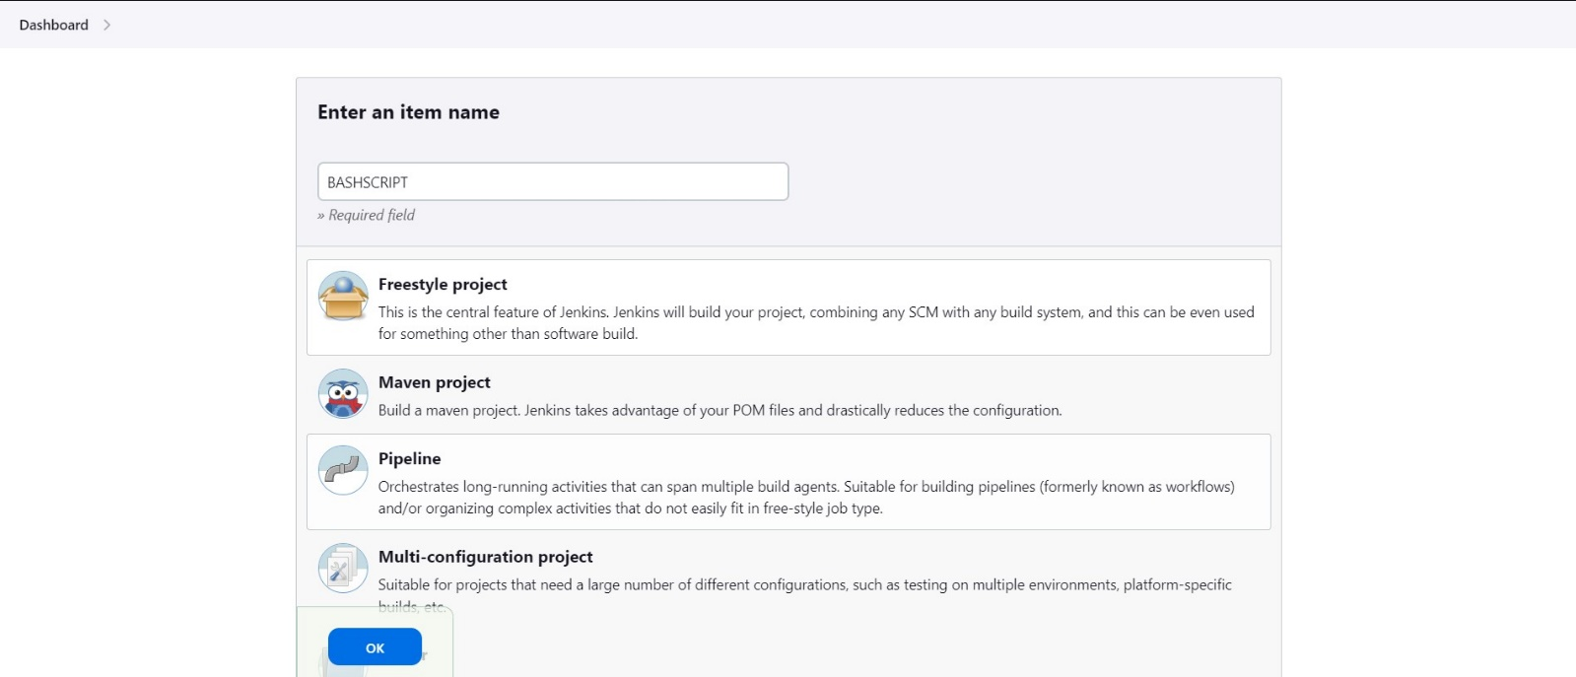

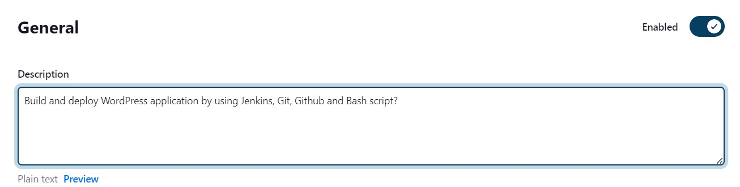

2.In source code management select none because its as no interaction between the git and Jenkins. And in execute shell paste bash script as shown below. Where it as git to install and git clone and <**docker-compose up -d>.**

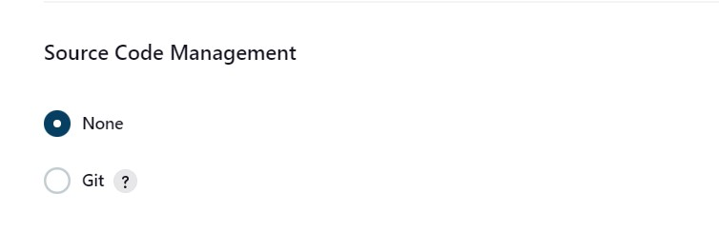

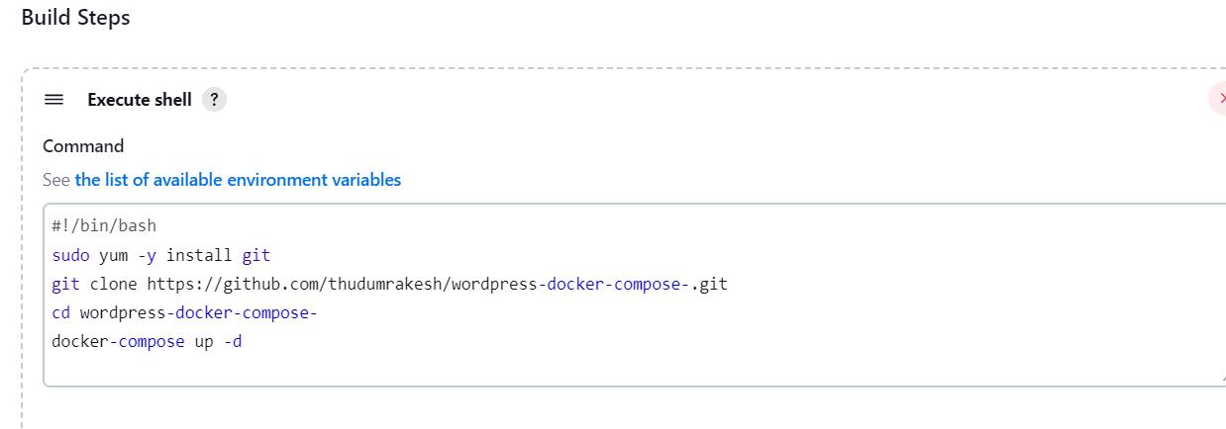

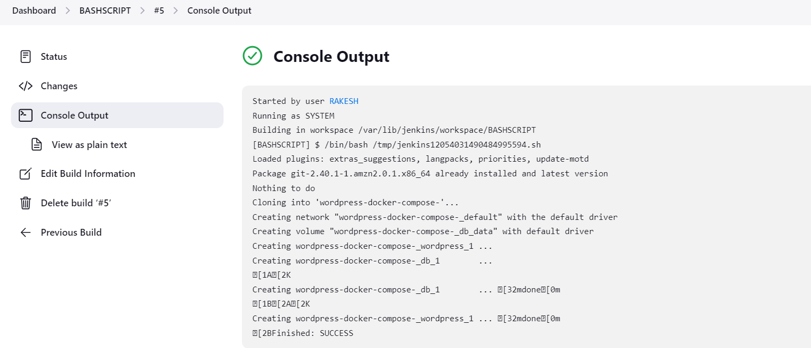3.After success build copy the Ip of instance browse it browser then it open a wordpress welcome page as shown in below.

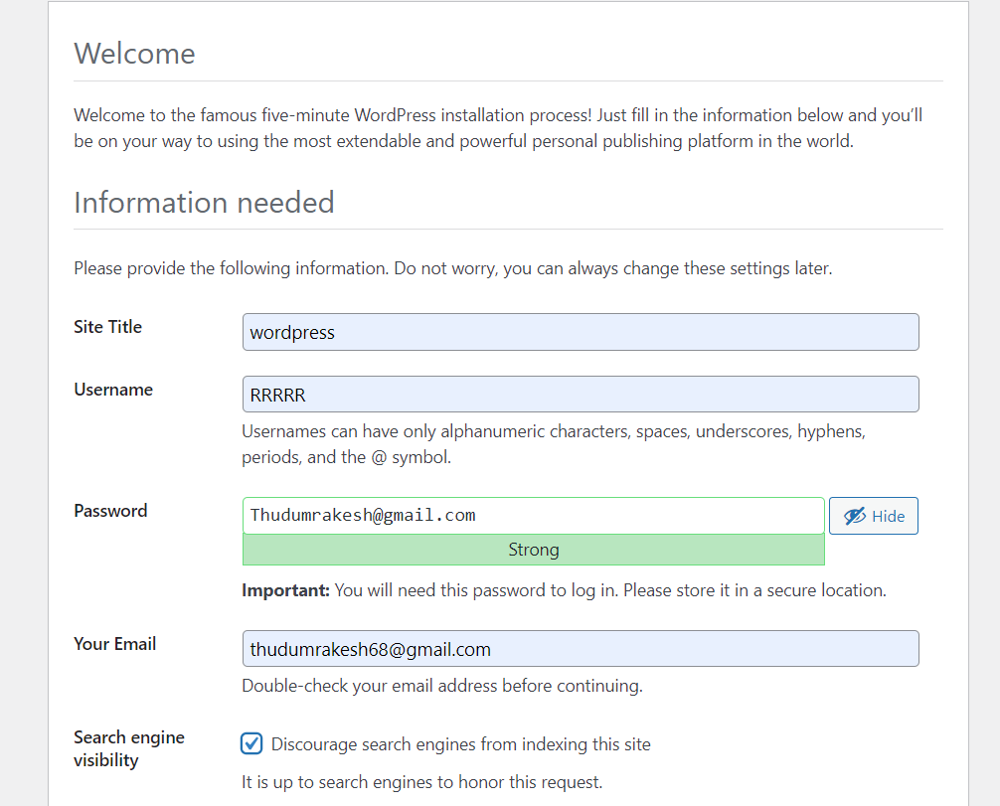

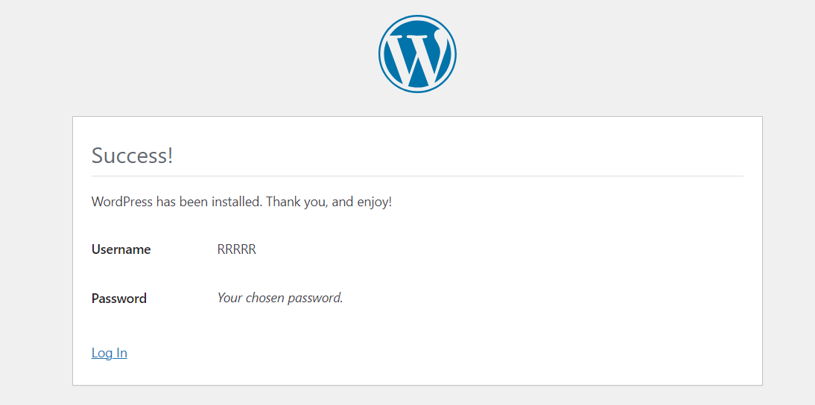



**7. BUILD AND DEPLOY WEB APPLICATION WITH   
 JENKINS, GIT (PERIODICALLY, POLL SCM,   
 WEBHOOKS METHOS).**

1.Login in to Jenkins. Click on create 2 new item and select pipeline first is clone job where we need to clone repo from git hub and build job where it start building the application.

2.While creating a build job scroll down there, we can copy from option for build job give name of previous job as shown below. In source code management selected git.

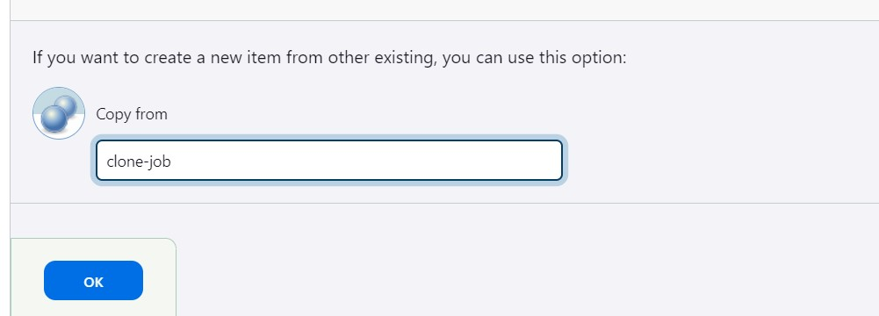

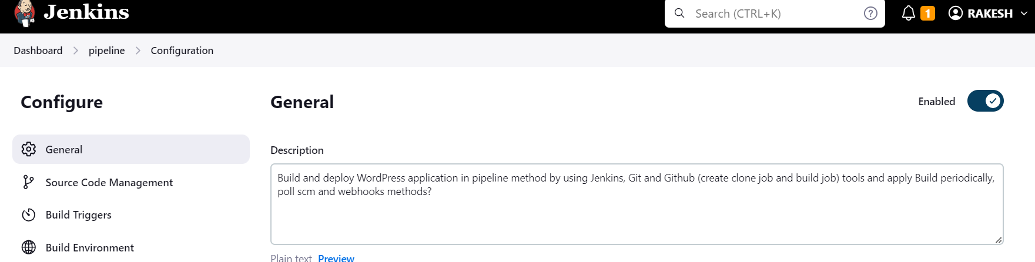

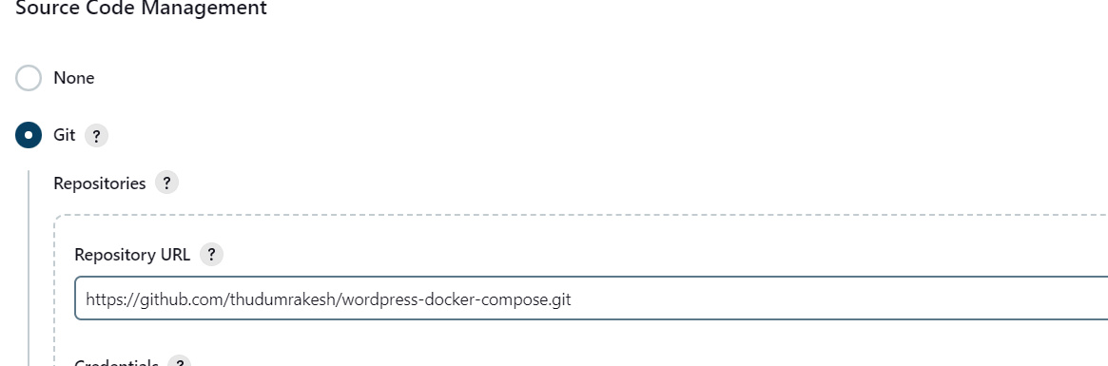

2.While creating a build job scroll down there, we can copy from option for build job give name of previous job as shown below.

3.In build triggers select built after other projects are built as shown give name of I job in below projects to watch.

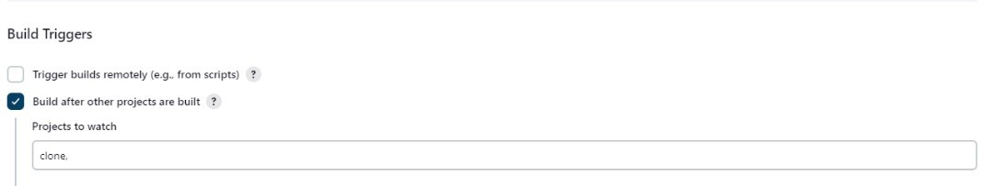

4.In build steps execute shell give command **<docker-compose up -d >** click on save.

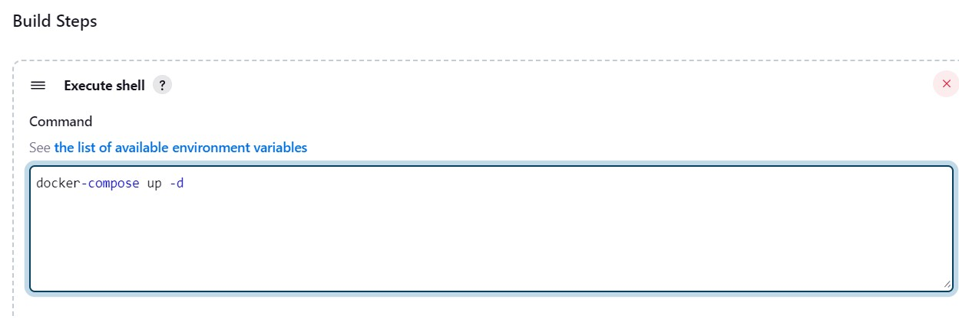

5. click on build now for clone job then it automatically build another job.

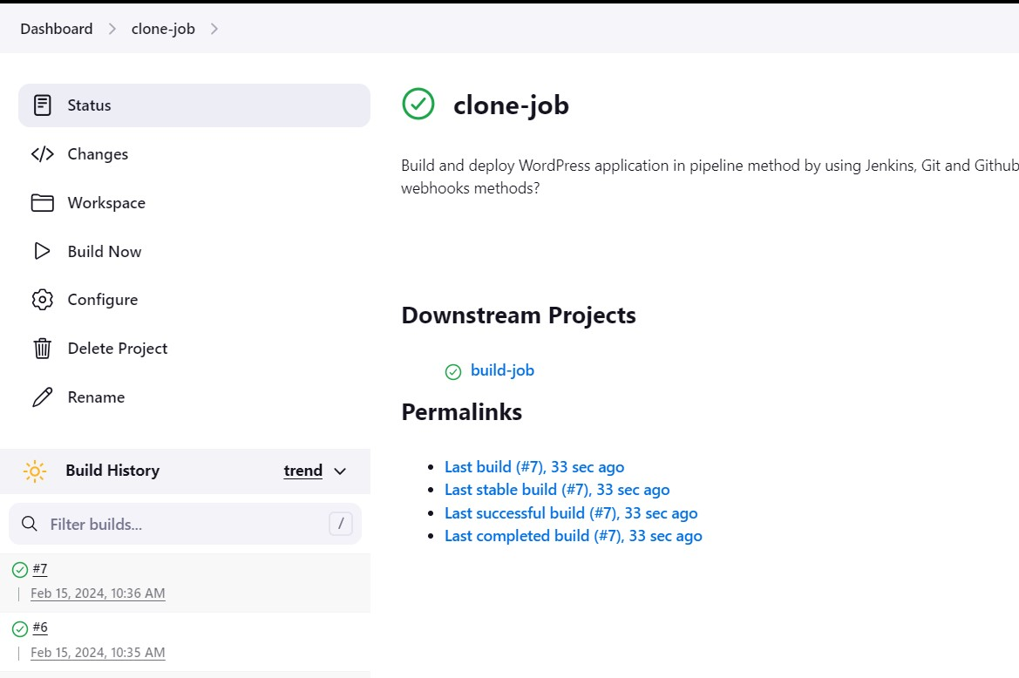

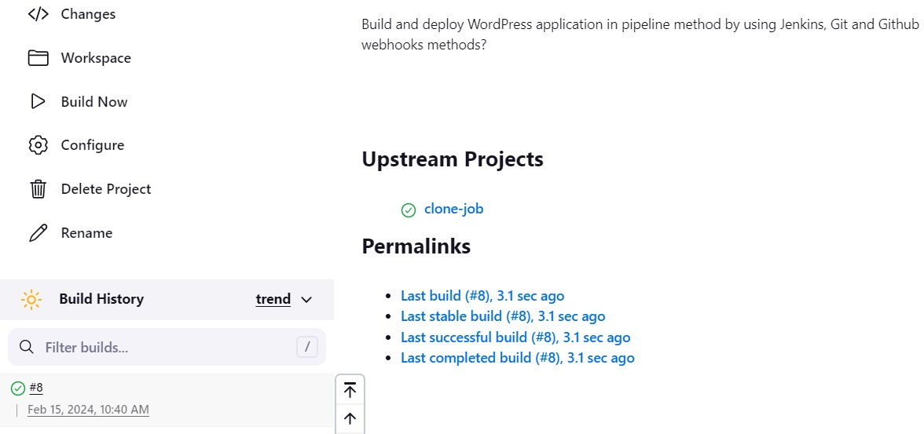

BUILD PERIODICALLY

1.Same as above select build periodically in build triggers and schedule as every minute by give 5 stars as shown below. Click on save then after every minute it build automatically as shown below.

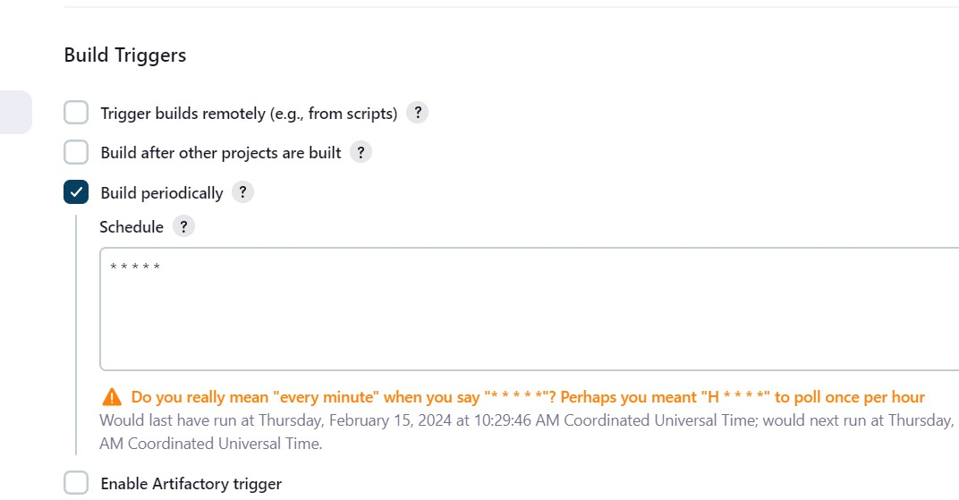



**WEBHOOK**

1.Login into git hub select the repo and click on setting on left we see webhooks option click on it, add webhook.

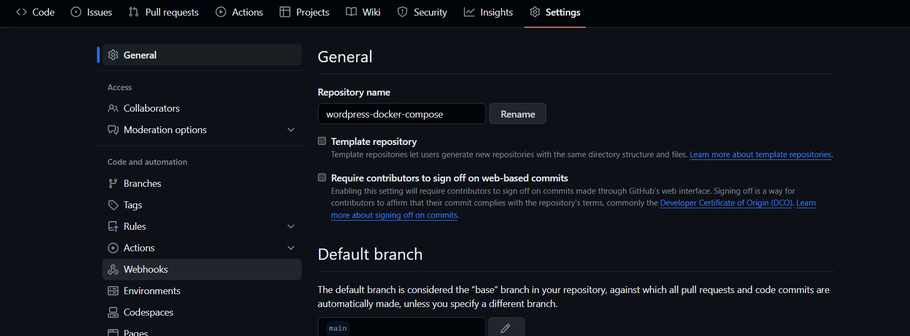

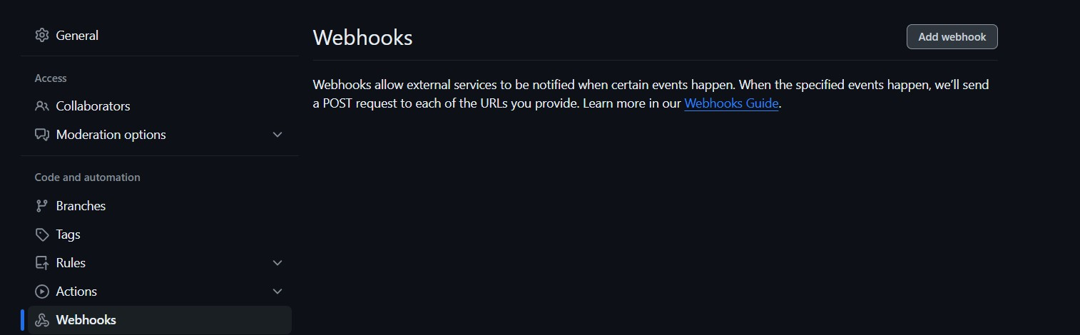

2.Then it opens a payload URL then give the Jenkins Ip address/git hub-webhook/ select content type as application/json select just the push event as then it creates a webhook. If any changes made in repo it automatically build it as shown.

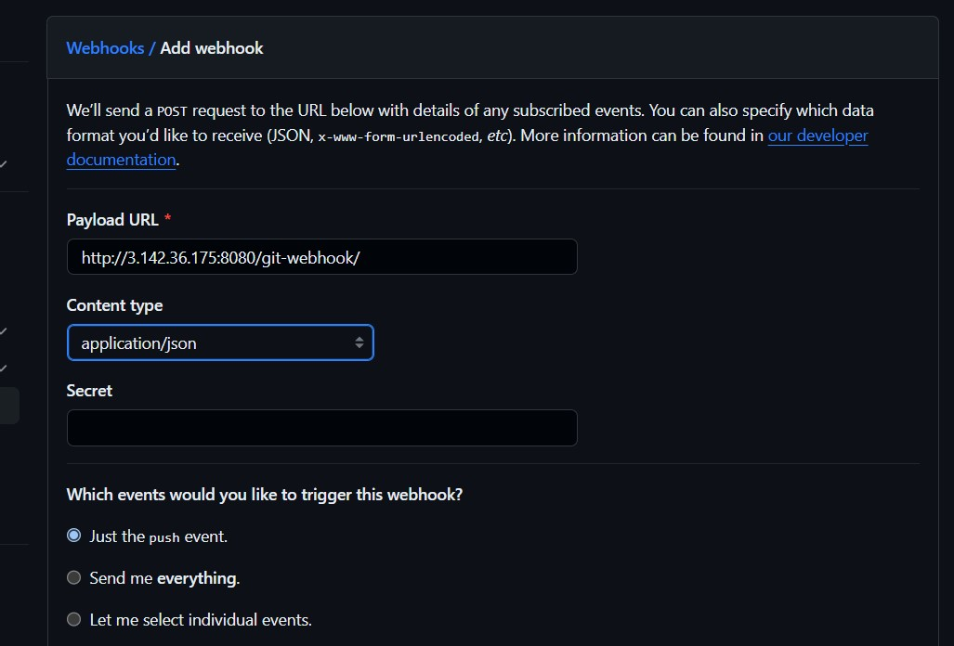

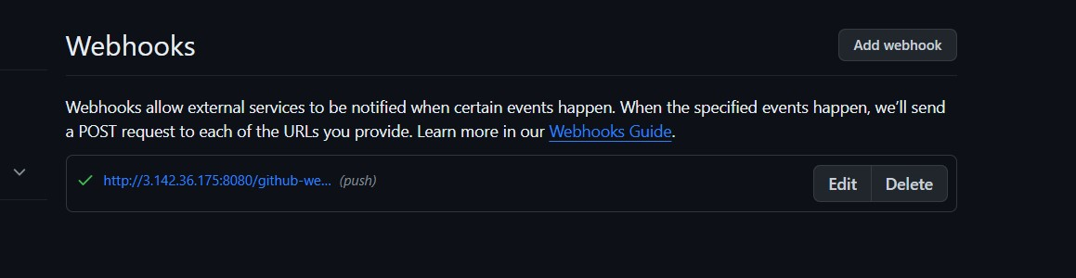

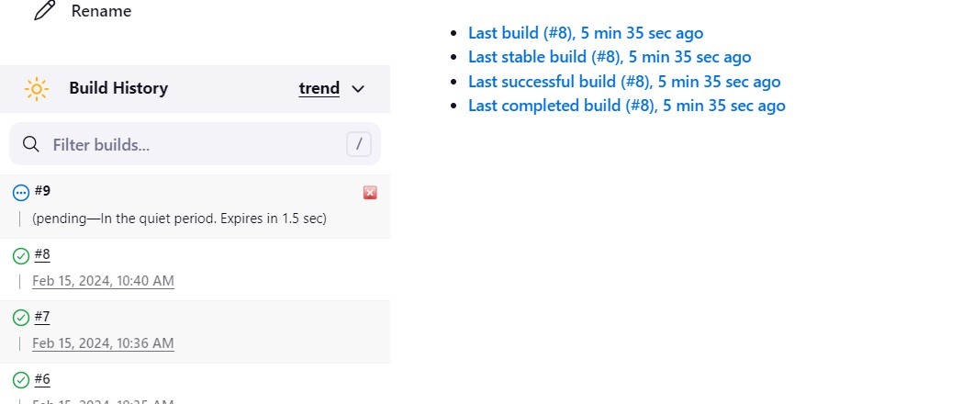

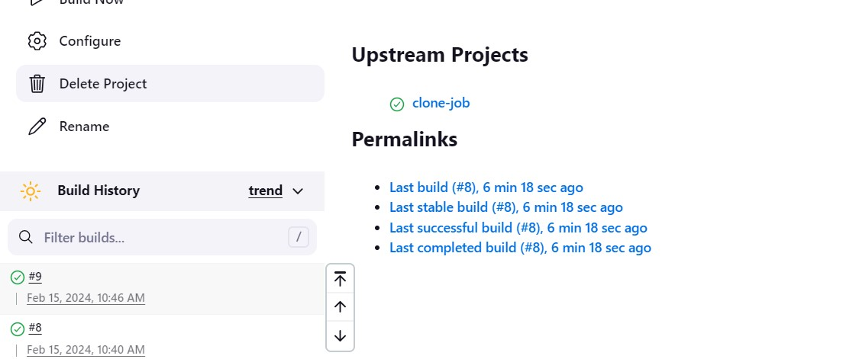

POLL SCM

1.Same as above but select poll scm in build trigger abb schedule to it if any changes are made in repo after 1 minute it start building automatically as shown.

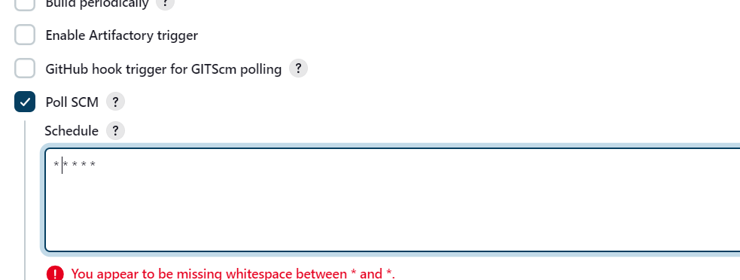

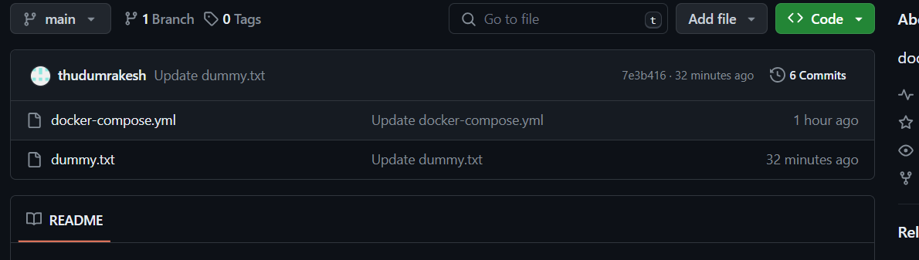

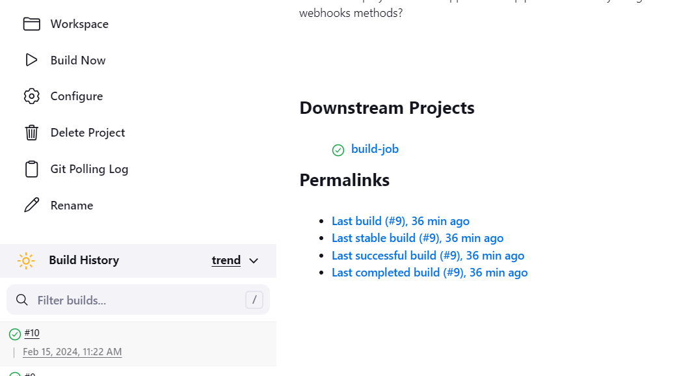

**8. Build and deploy WordPress application by using   
 Terraform**

* **Create entire n/w of vpc, instances and data.sh and push terraform code in Github**

1. 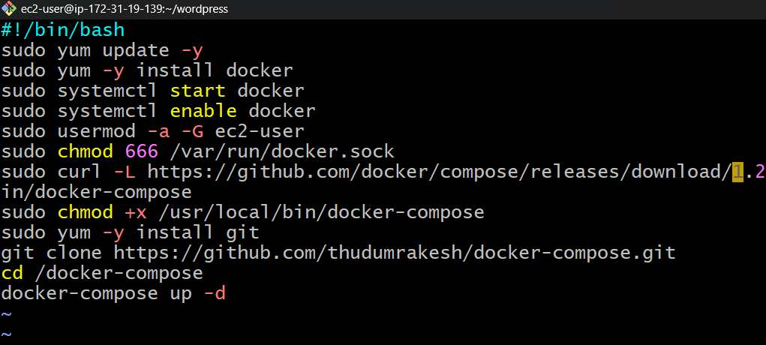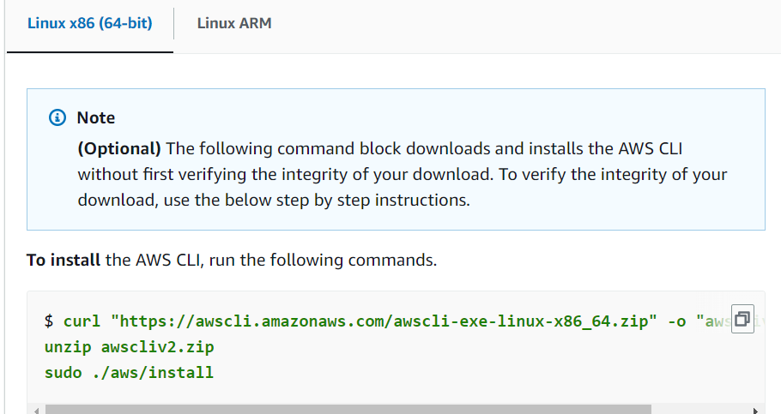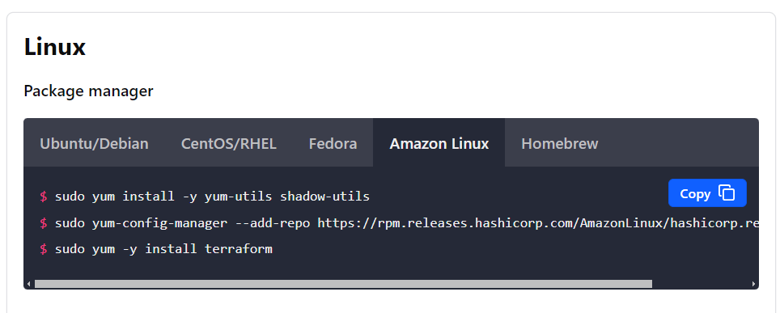Launch instance and access it with SSH. Create scripts in data.sh as below remaining are cloned from previous project.

**2.**Install aws cli and terraform from browser.

3.Check the version of both terraform and aws cli and installed.

4. Now create .tf file in directory as shown in above and a data.sh file as shown   
 below.

5.Initiate terraform with **<terraform inti>**

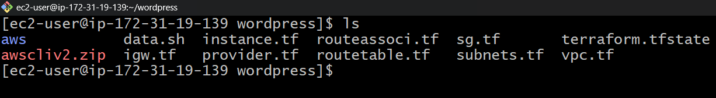 **<terraform fmt>  
 <terraform validate>  
 <terraform plan>  
 <terraform apply>**  
 then it created all resources in console.

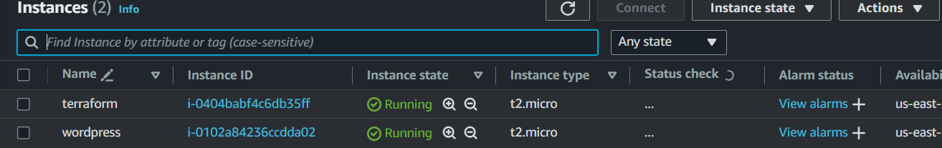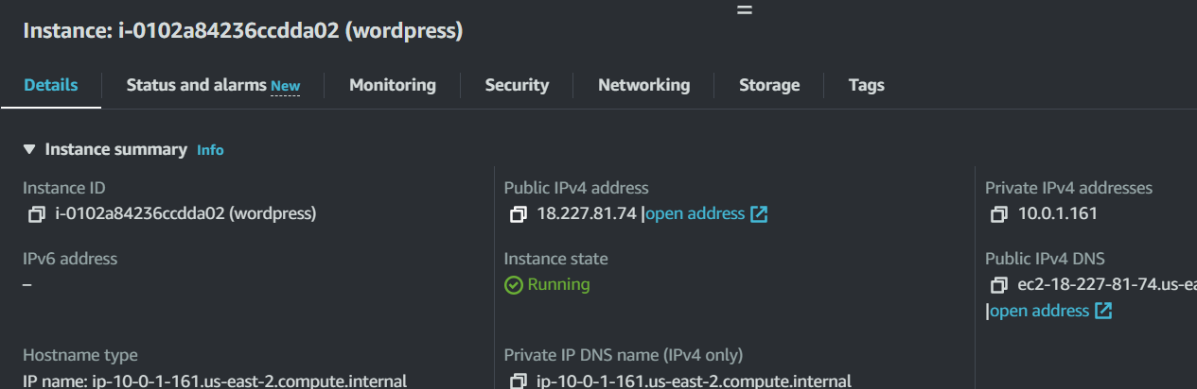6. Terraform created a instance, copy the instance Ip and browse it then it open it open word press as shown.

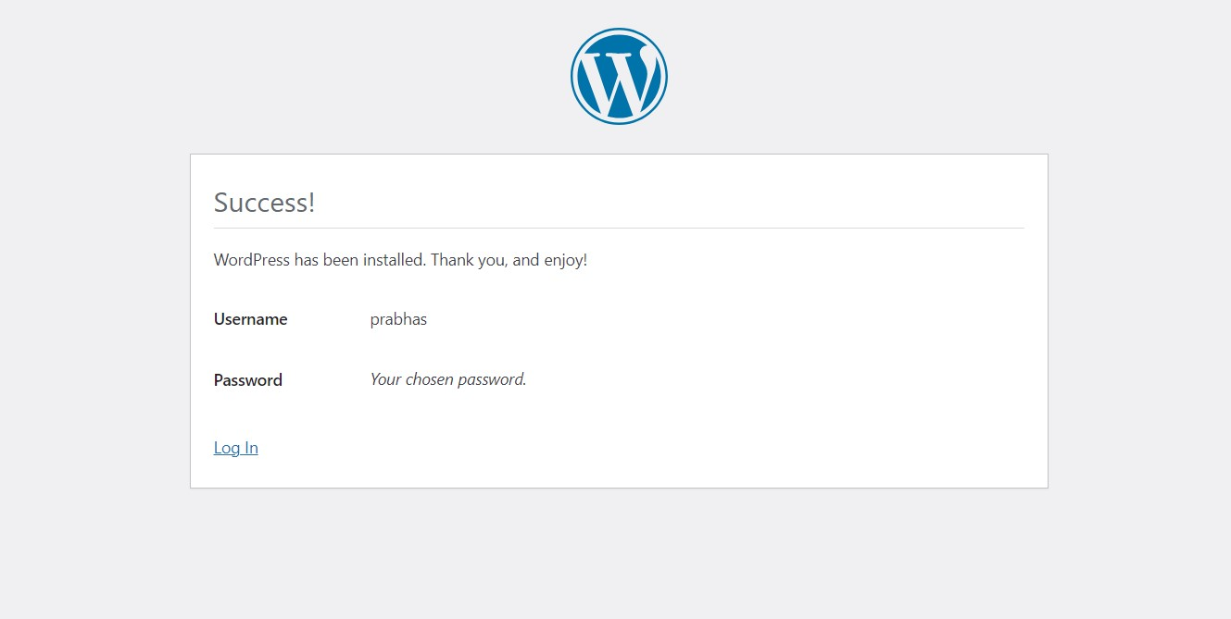

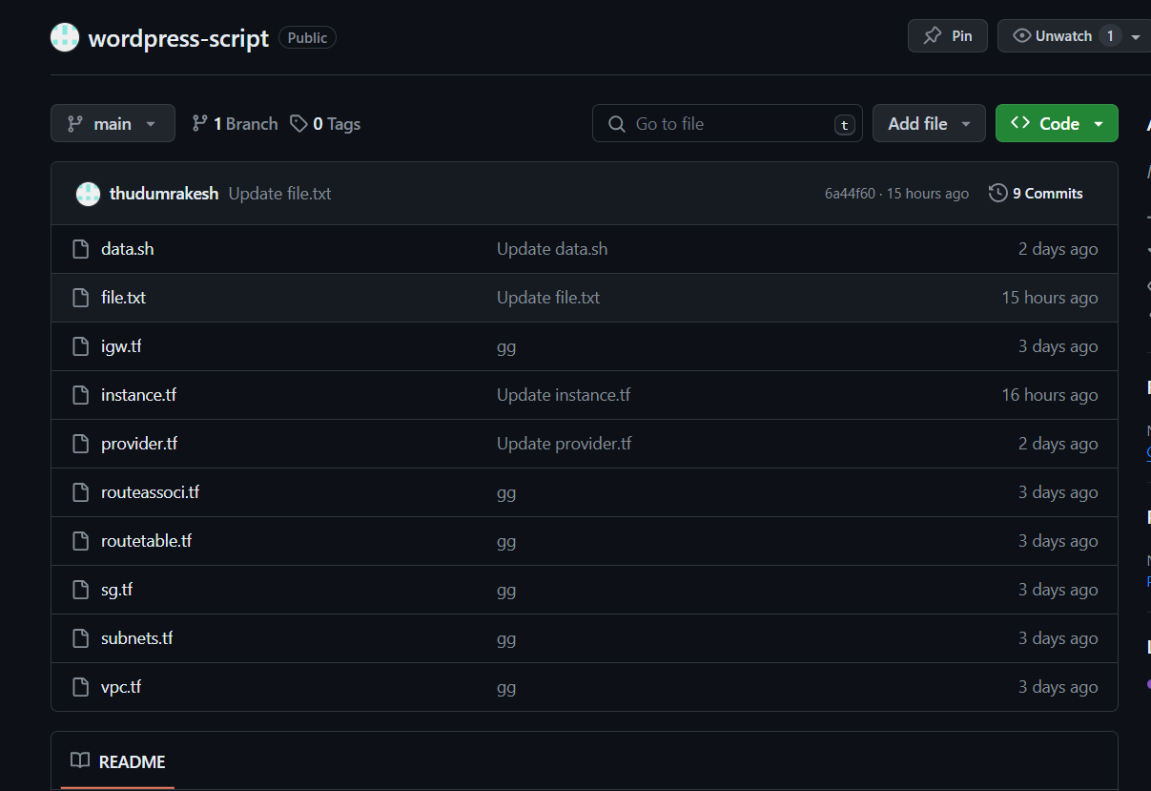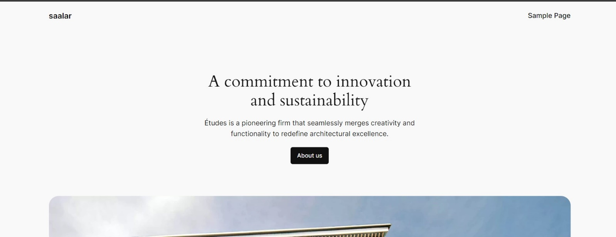7. And push the script to git hub.

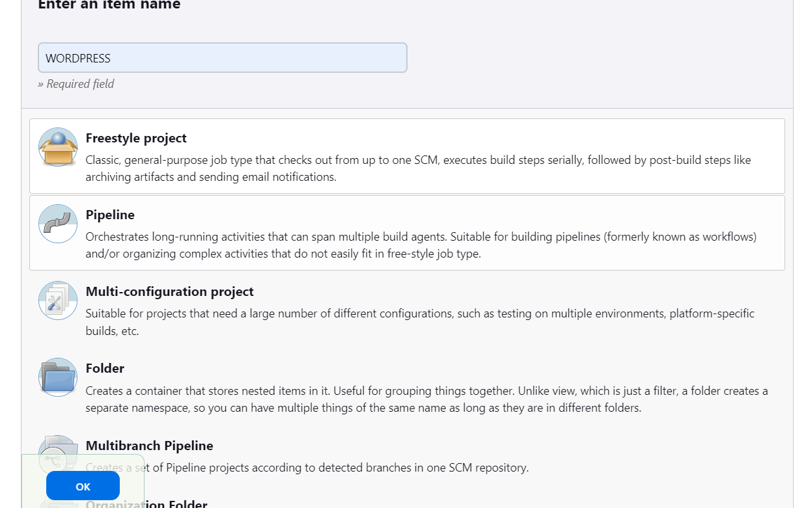**9.Build and deploy WordPress application by using Jenkins, Git, Github and   
 Terraform.**

1.Login into Jenkins with port Ip:8080 and click on new item give name as WordPress as shown in figure. And click on save.

2. Create the new item as WordPress and in source code management select git

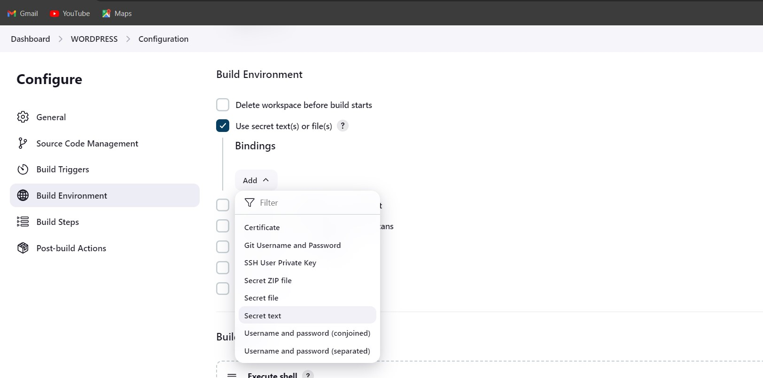3.In build environment select use secret text. And click on add select secrete text.

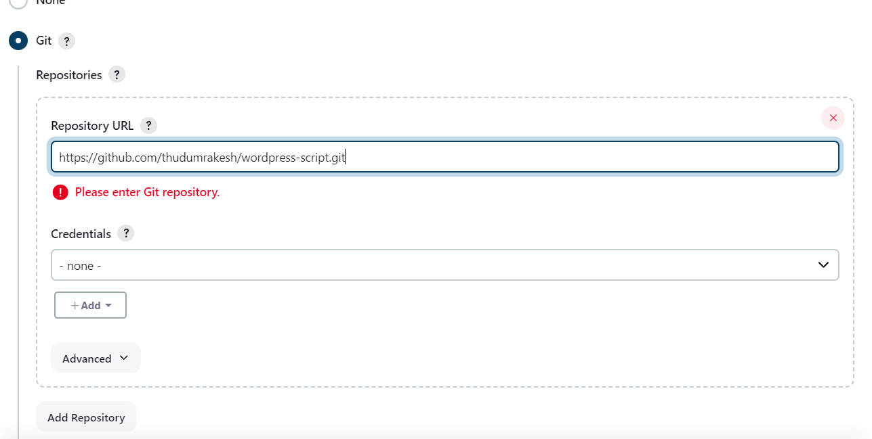4.In secret text give ID as AWS_ACCESS_KEY_ID credentials as   
 AWS_ACCESS_KEY_ID and AWS_SECRET_ACCESS_KEY specific   
 credentials AWS_SECRET_ACCESS_KEY as shown.

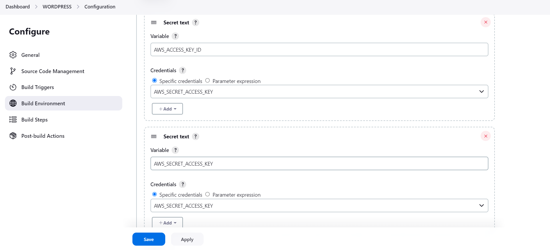

5. In build execute shell give command of terraform.

**<terraform int><terraform validate><terraform apply –auto-approve>**

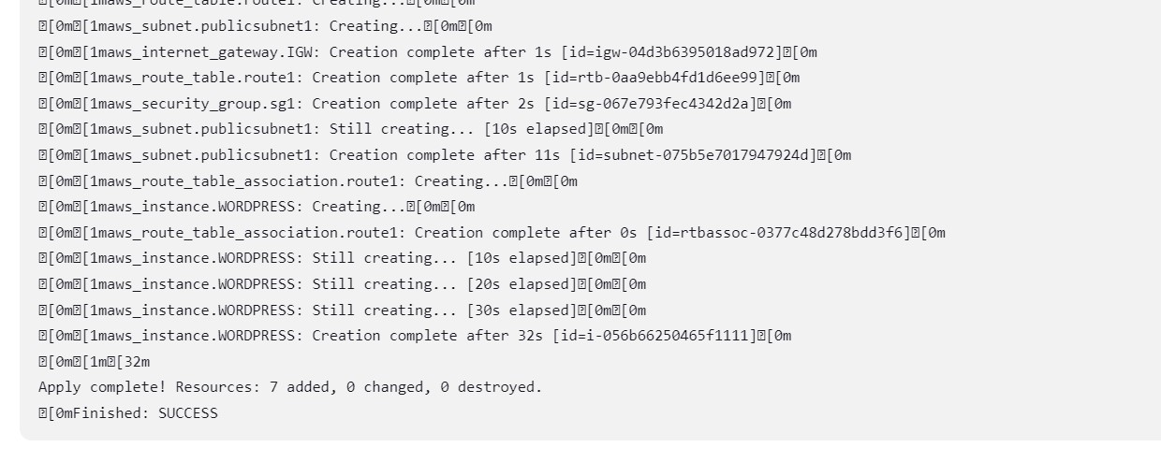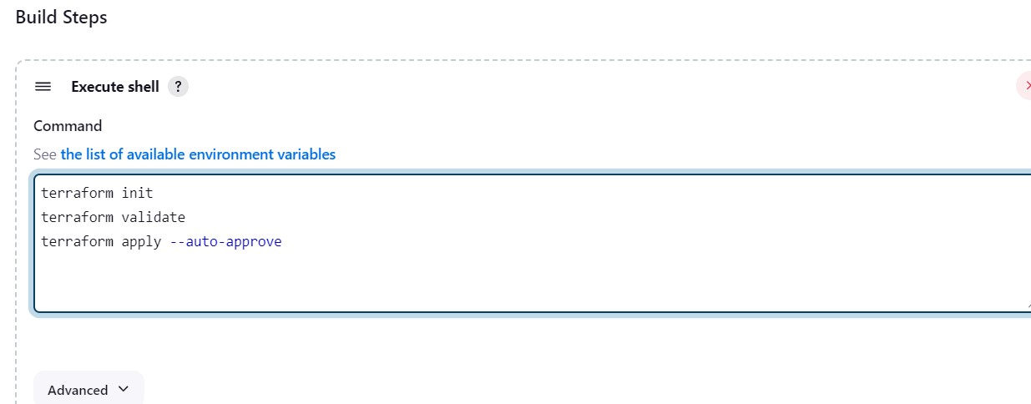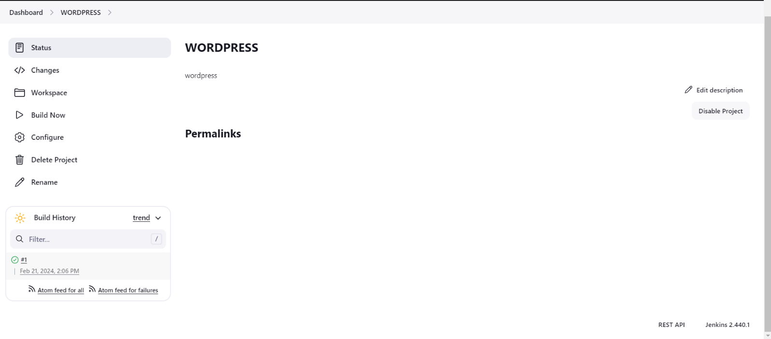6.Click on build now then it start building, then it creates a instance copy the instance IP and browse it it opens a WordPress application.

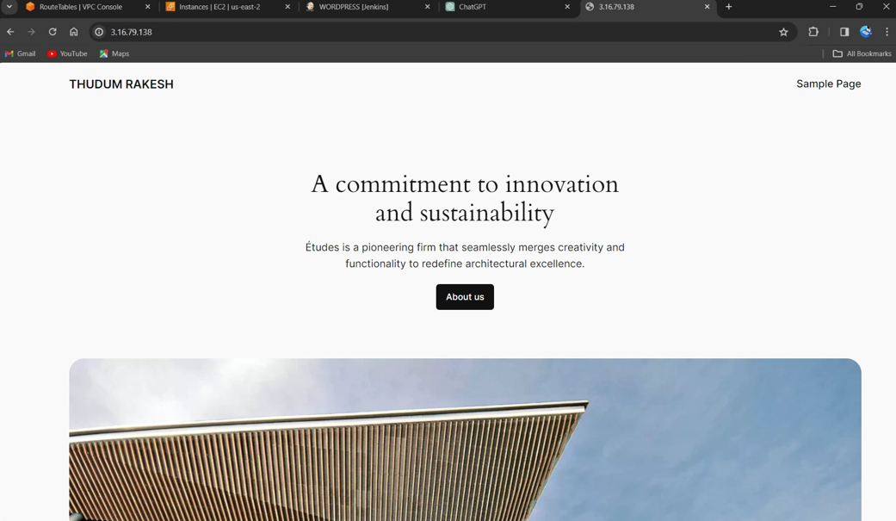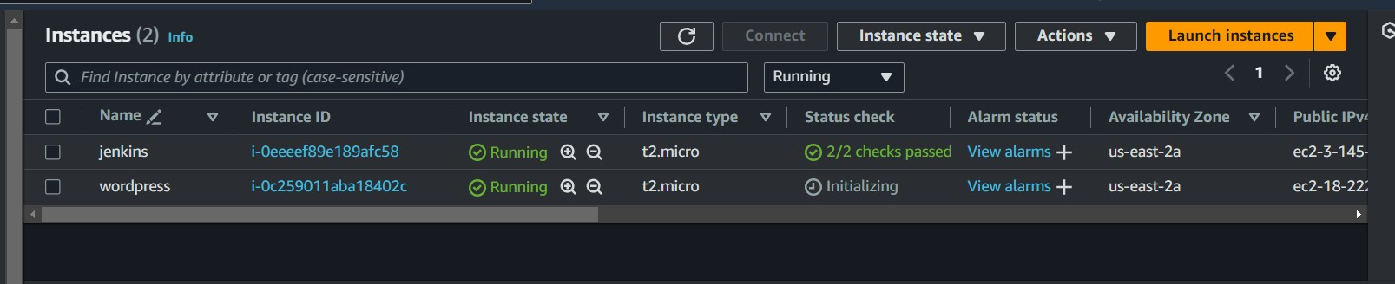

**10.Build and deploy WordPress application by using Docker, Docker-compose file and create the image push that created image into docker hub registry and host the image through k8’s (declarative manifest method)?**

* Login to amazon console, launch instance access through git bash.
* Install docker and start and enable it and check the status of it.

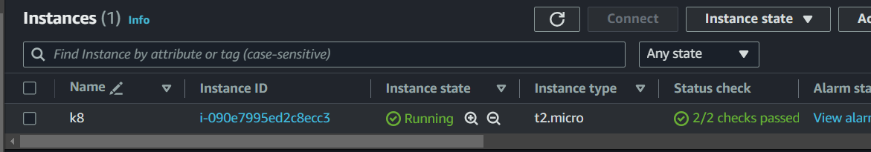

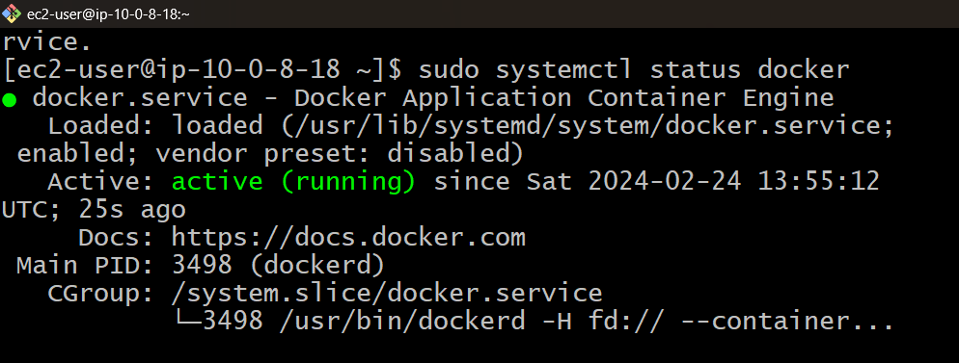

* Now add the ec2-user to docker group to run commands

<sudo usermod –aG docker ec2-user>

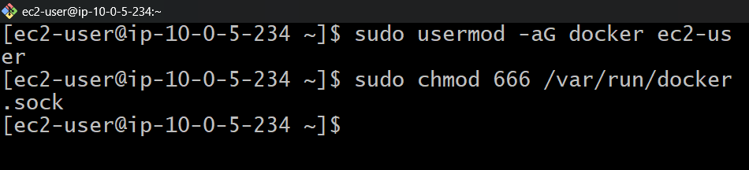

* Now add the ec2-user to docker group to run commands

<sudo usermod –aG docker ec2-user>

* Now create docker file with command <vi dockerfile

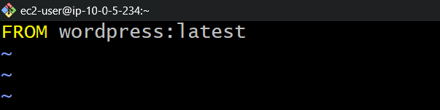

* Now use the command <docker build -t rakesh.>
* Then it starts building images
* Check the images with <docker images>.

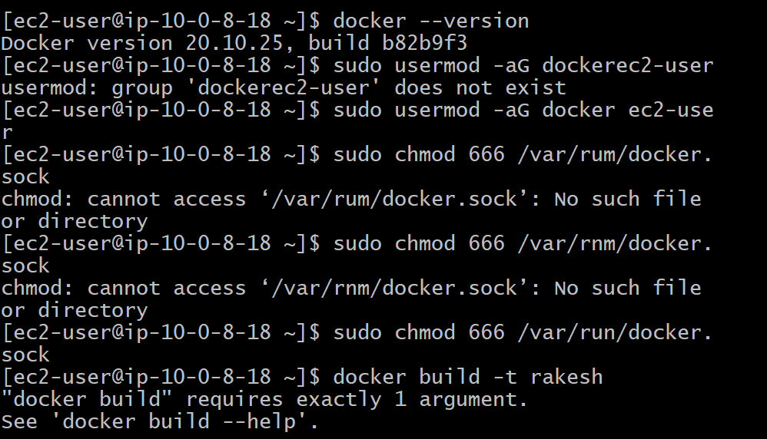

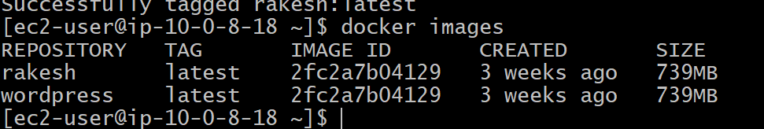

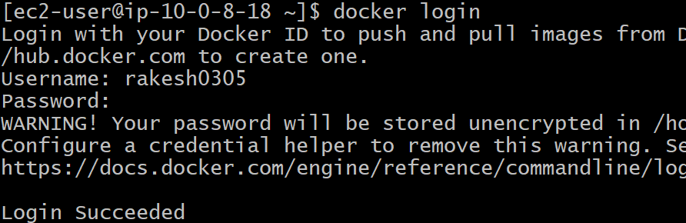

* Then push these images in to docker hub we need to login first with command **<docker login>** give the credentials login get succeeded.
* Then push the image to docker hub with command **<docker tag rakesh rakesh0305/word>.**

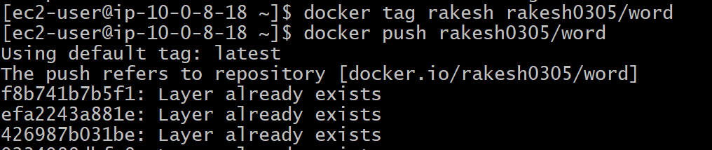

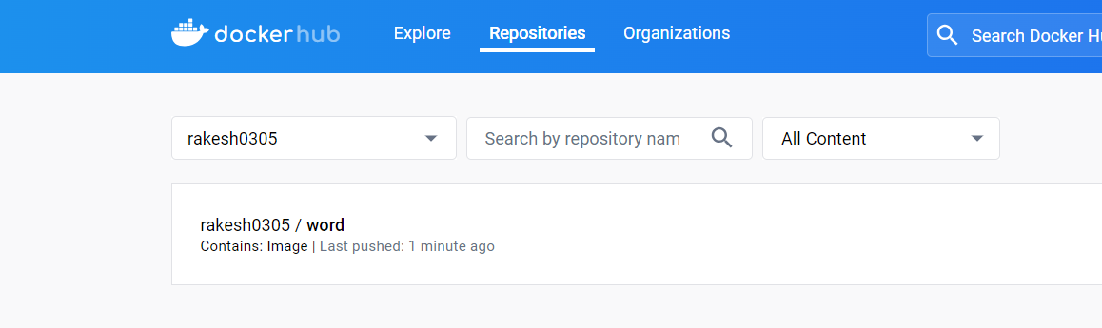

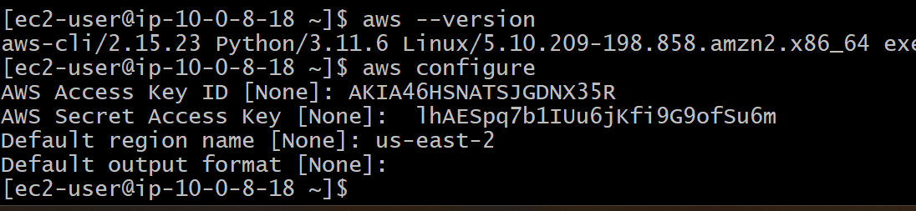

* Install kops and kubectl from browser and check versions.

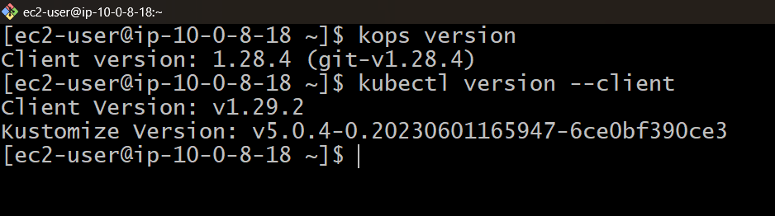

* Create a s3 bucket with command of <aws mb s3://k8-rakesh>. And check the list of buckets

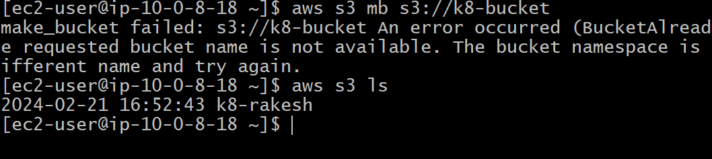



* Now use command <export KOPS_STATE_STORE=S3://k8-rakesh> kops know where to store all retrieve state information if the k8 cluster.
* Generate key pair with command <ssh-keygen> is a versatile tool that can be used in a Kubernetes environment to generate SSH key pairs for securely accessing and managing cluster nodes**.**

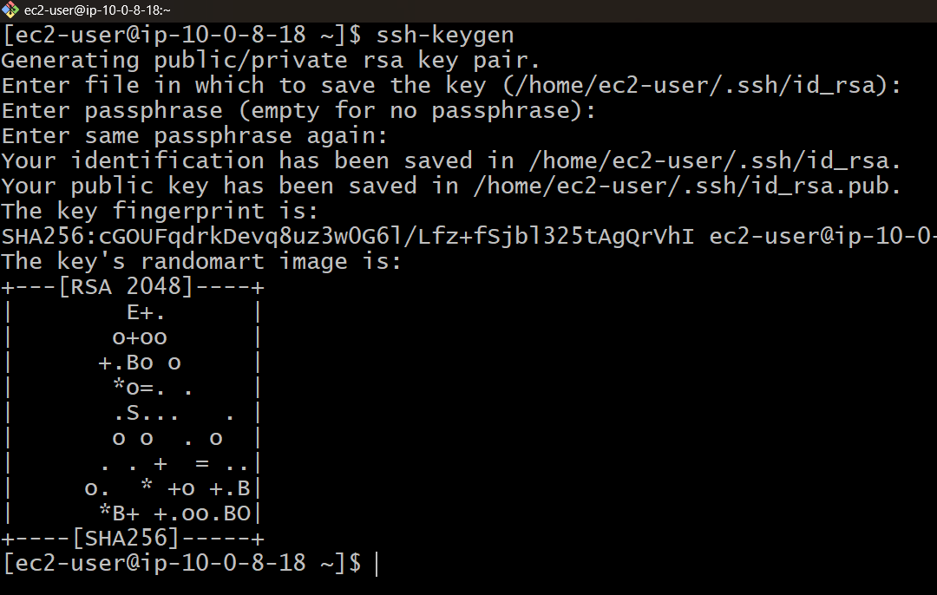

* **Create a file of deployment. File, mysql.file and service.yml**

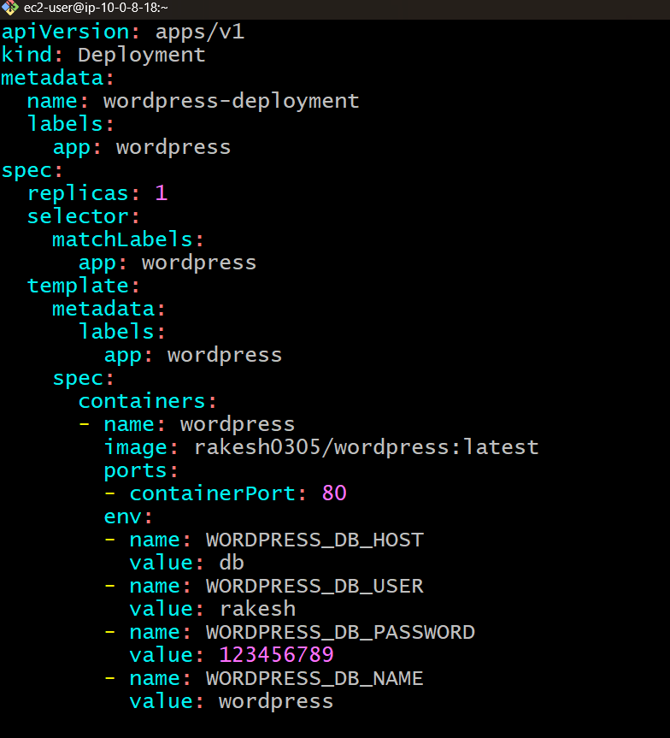

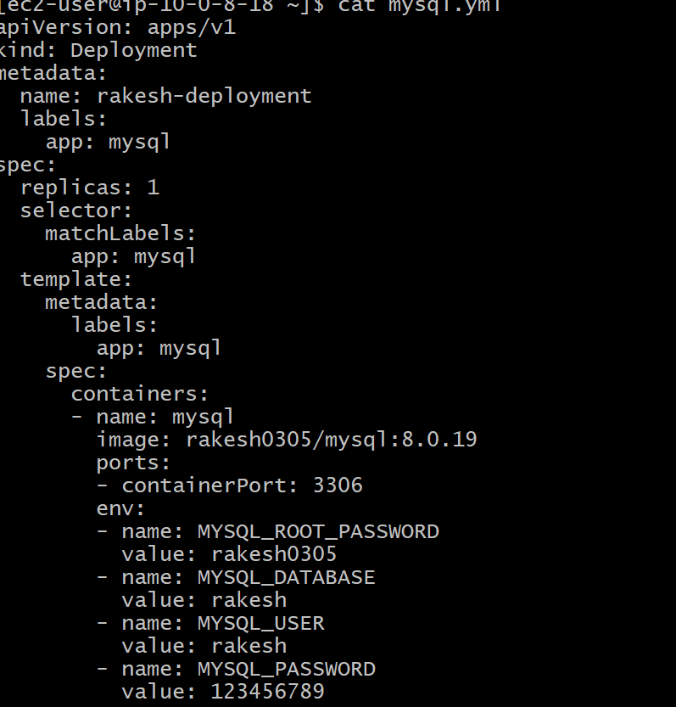

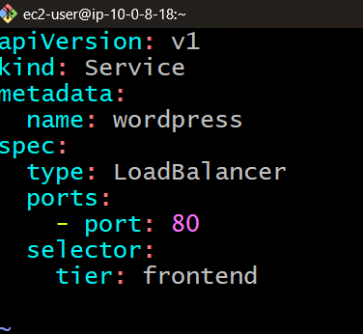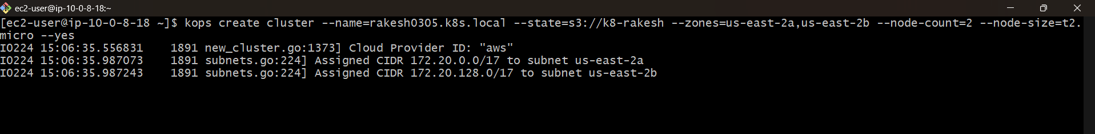

* **Create a cluster** with **<kops create cluster --name= rakesh0305.k8s.local --state s3://k8-rakesh –zones=us-east-2a,us-east-2b –node-size=t2.micro --yes**

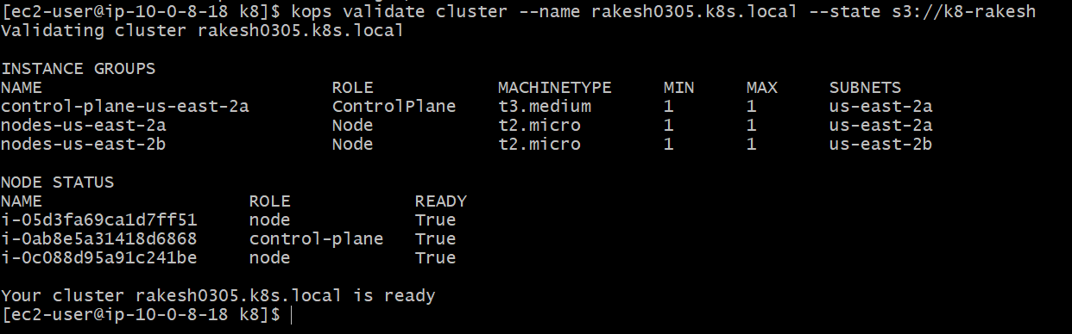

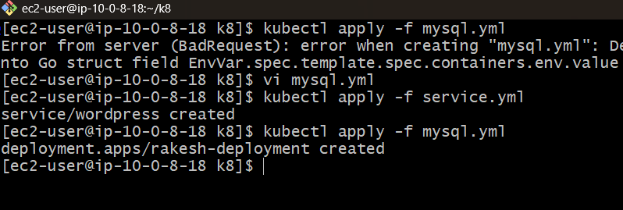

* 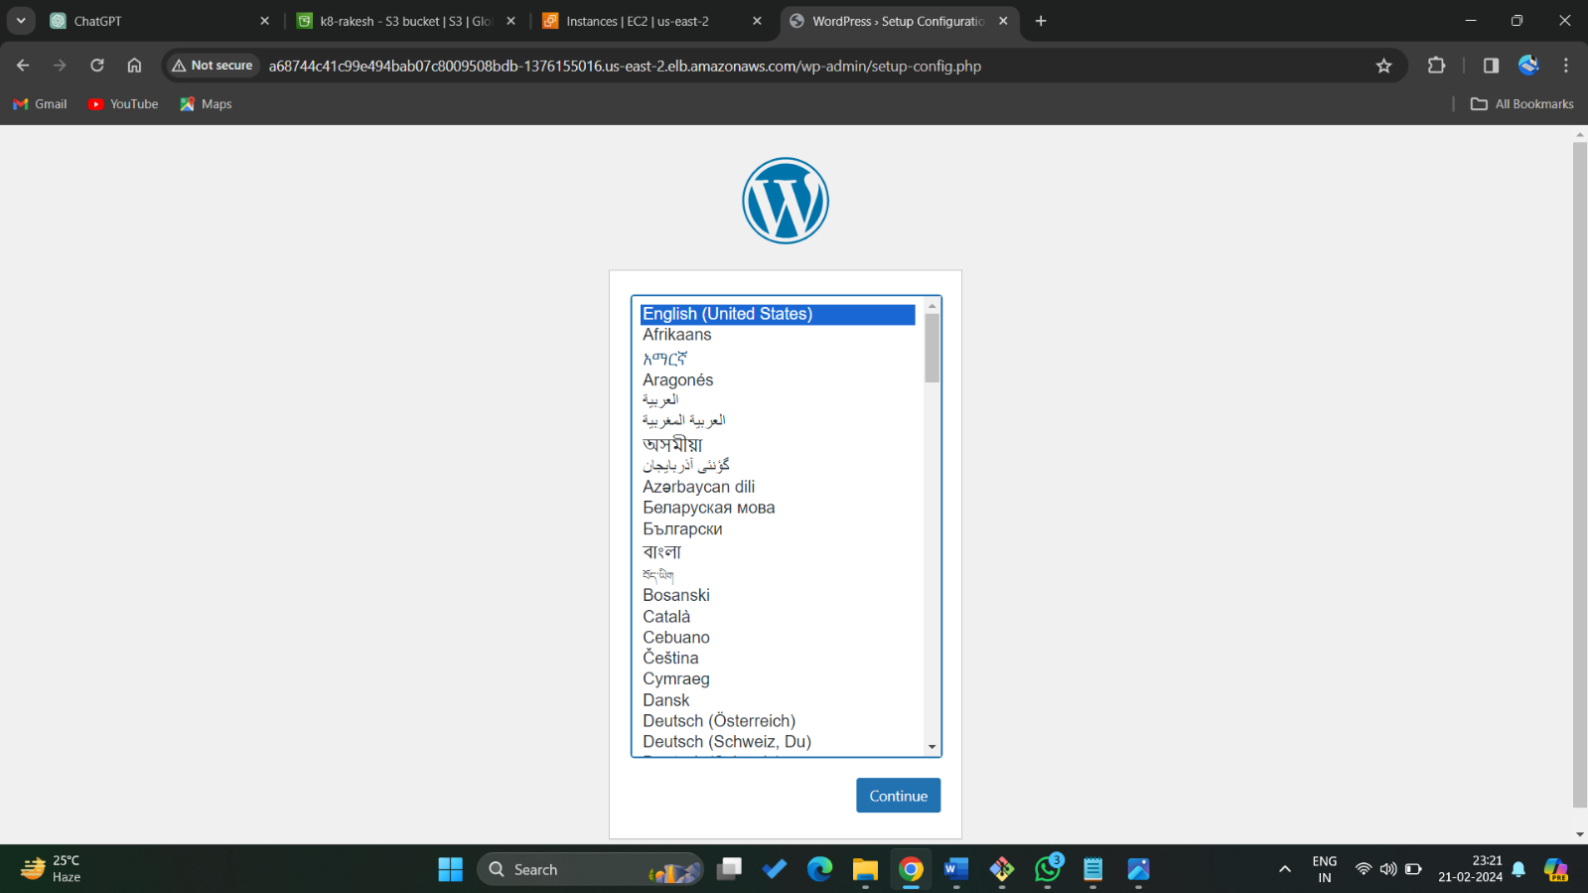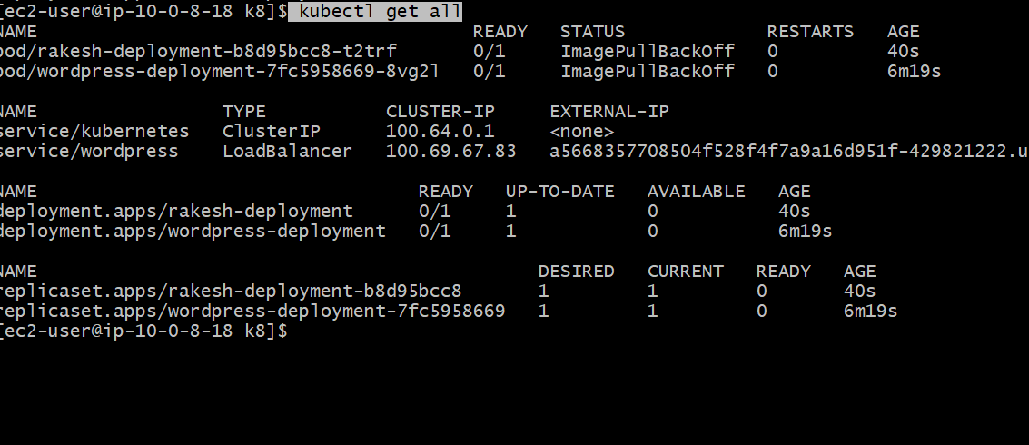Now deploy in to cluster **,<kutectl apply -f mqsql.yml>  
  <kutectl apply -f service.yml>,<kutectl apply -f service.yml>**

**11.Github and Terraform (create clone job and build job) tools and apply Build periodically, poll scm and webhooks Build and deploy WordPress application in pipeline method by using Jenkins, Git, methods.**

* Login amazon console, Launch instance and access it through git bash.
* Install terraform and aws cli and Jenkins and start and enable Jenkins.

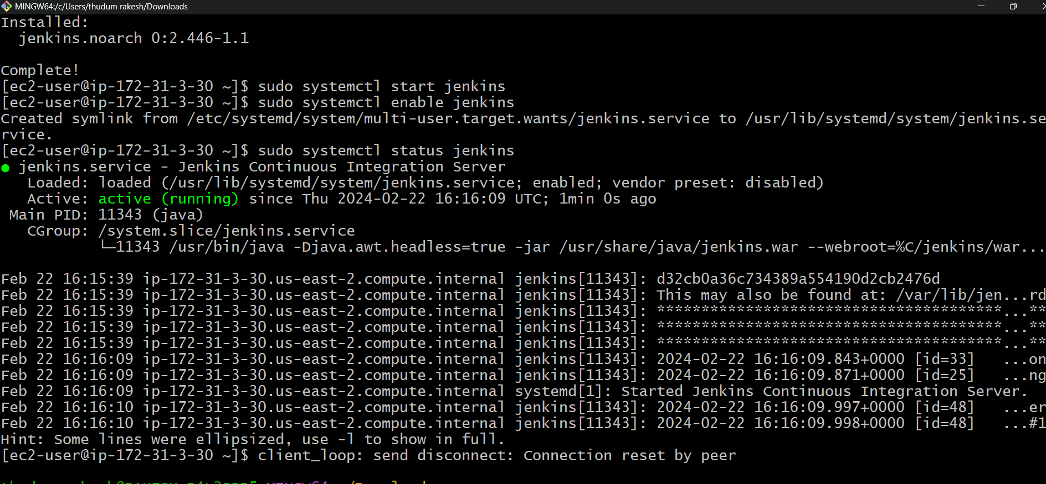

* Click on new item give the name as terraform.
* In source code management select git paste and repository URL.

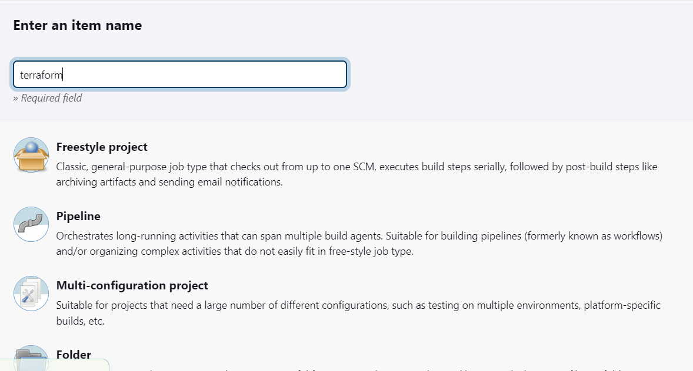



* In Build environments select use secret text add access key and secret key in it.



* **In execute shell give commands as**

**<terraform init>**

**<terraform validate>**

**<terraform apply –auto-apply>.**

* **Click on save and build now.**
* **In console resource got created.**

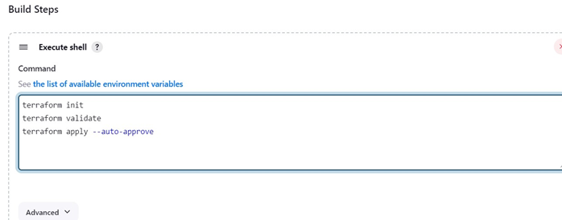

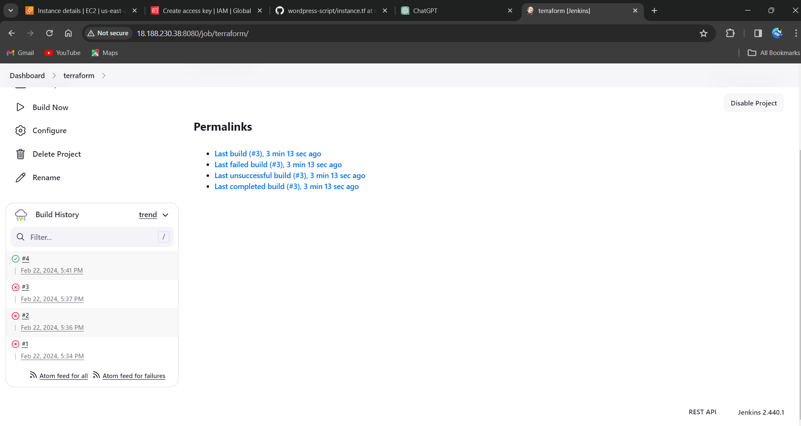

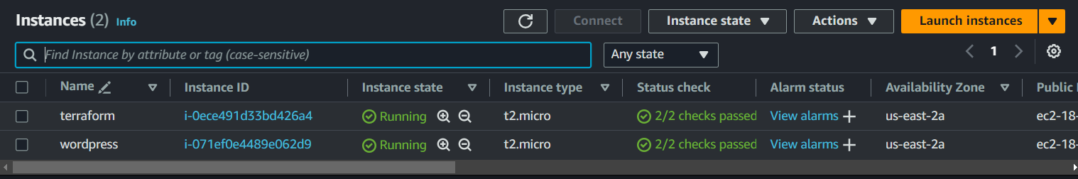

**Build periodically**

* Go back and in configure select build trigger in it select build periodically.
* And schedule time and click on save.
* After minute it starts building.

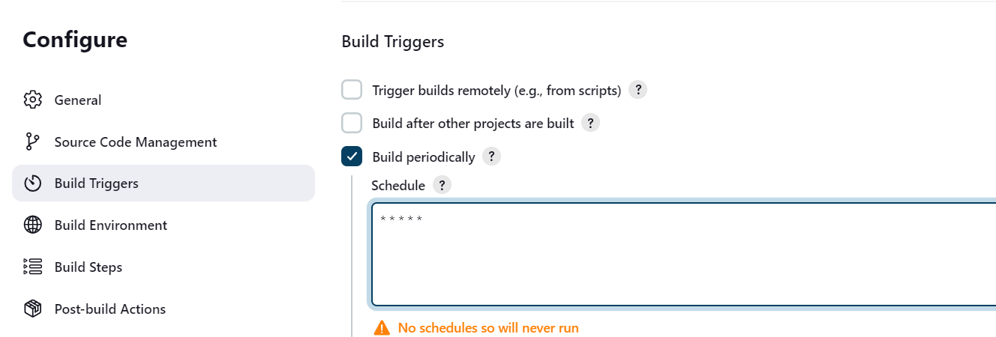

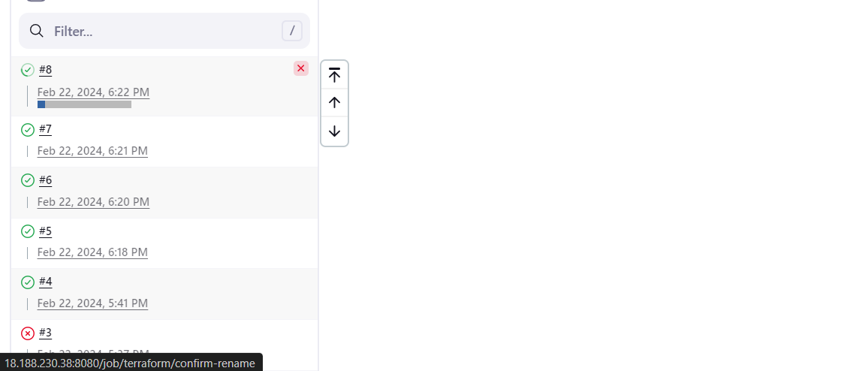

**Poll scm**

* Go back and in configure select build trigger in it select poll scm.
* And schedule time and click on save.
* After changes made in git hub repo it starts building.

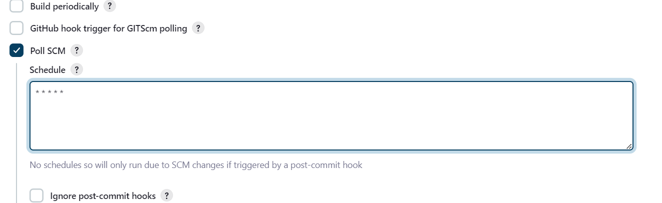

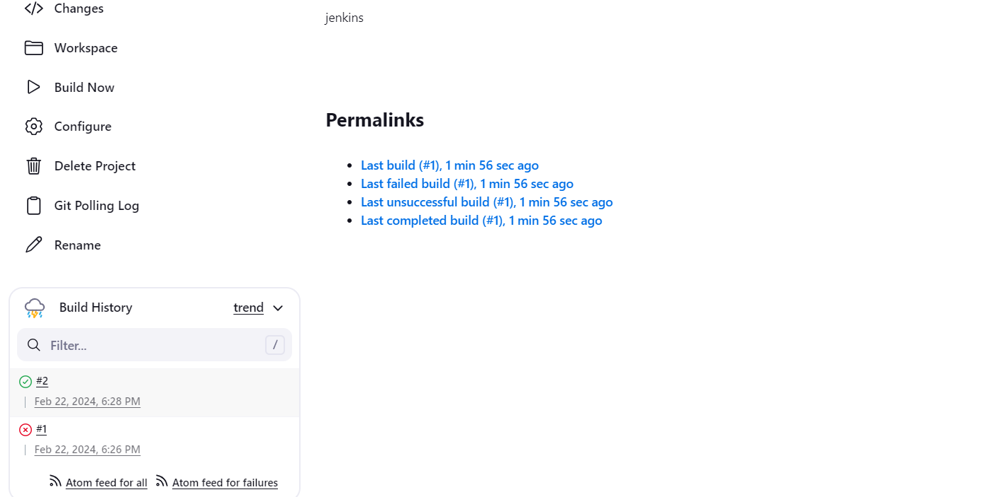

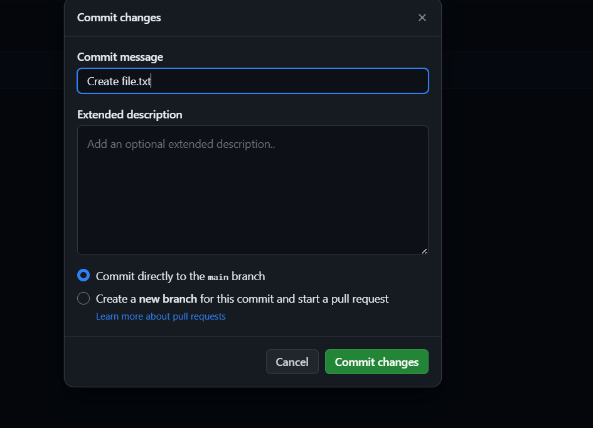

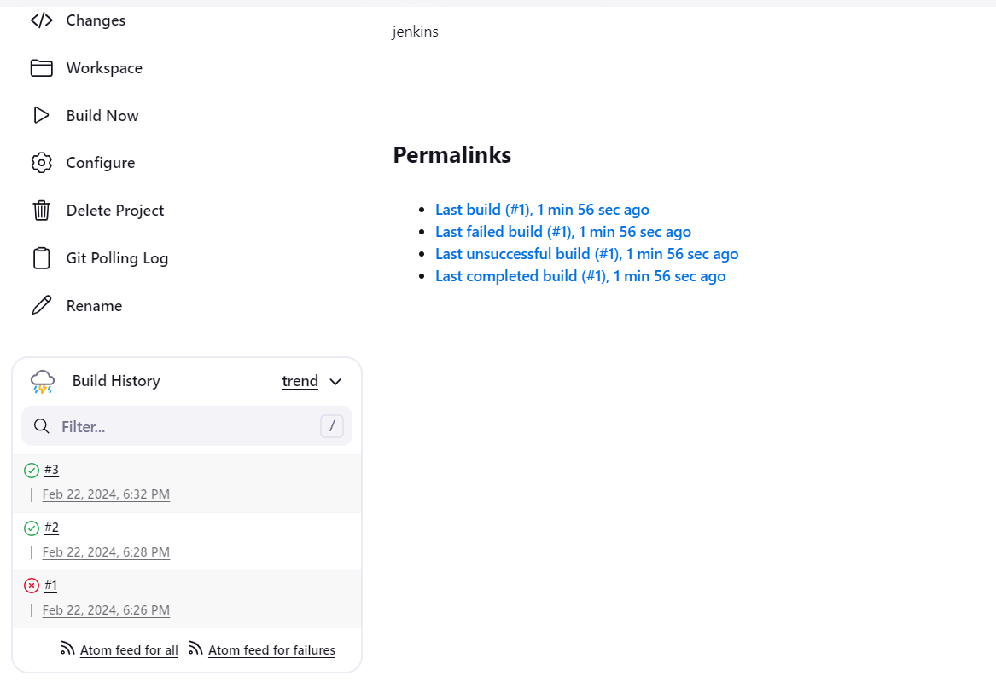

Webhooks

1.Login into git hub select the repo and click on setting on left we see webhooks option click on it, add webhook.

2.Then it opens a payload URL then give the Jenkins Ip address/git hub-webhook/ select content type as application/json select just the push event as then it creates a webhook. If any changes made in repo, it automatically build it as shown**.**



